BENEFITS OF REDUCED PREMATURE MORTALITY FROM DECREASES IN PM2.5 AND OZONE IN THE UNITED STATES FROM 1999 TO 2015

M. Omar Nawaz

A thesis submitted to the faculty at the University of North Carolina at Chapel Hill in partial fulfillment of the requirements for the degree of Master of Science in the Department of Environmental Science and Engineering in the Gillings School of Global Public Health.

Chapel Hill

2018

Approved By:

J. Jason West

Marc Serre

William Vizuete

© 2018

M. Omar Nawaz

ALL RIGHTS RESERVED

ABSTRACT

M. Omar Nawaz: Benefits of Reduced Premature Mortality from Decreases in PM2.5 and Ozone in the United States from 1999 to 2015

(Under the direction of J. Jason West)

Concentrations of PM2.5 and O3 have reduced dramatically in the United States (US) over recent decades from improved regulations and reduced emissions. Here annual mortality burdens and trends associated with PM2.5 and O3 in the US were assessed, comparing results for two datasets: a model simulation (NACR, 2009-2015) and a satellite-derived dataset (SAT, 1999-2011).

During their respective time periods, annual PM2.5-related deaths reduced by 45,700 [29200, 58000] and 33,800 [22200, 37100] for SAT and NACR respectively, corresponding to 4.9% and 7.9% decreases per year. For O3 from NACR, annual deaths reduced by 500 [600, 2700], or 0.6% per year. Reduced concentrations of PM2.5 and O3, as opposed to changes in population and mortality rates, were the major cause of these reductions, preventing 29,400 (2011, SAT PM2.5), 32,500 (2015, NACR PM2.5) and 2,100 (2015, NACR O3) deaths relative to the case where concentration remained unchanged from the first year.

ACKNOWLEDGEMENTS

This study was funded by the National Aeronautics and Space Administration Health and Air Quality Applied Science Team (NASA HAQAST) through the Tiger Team Project: “Demonstration of the Efficacy of Environmental Regulations in the Eastern U.S.” We also thank Raquel Silva and Susan Anenberg for helpful advice and relevant past work.

TABLE OF CONTENTS

LIST OF TABLES..........................................................................................................................vi

LIST OF FIGURES.......................................................................................................................vii

LIST OF ABBREVIATIONS......................................................................................................viii

CHAPTER 1: INTRODUCTION....................................................................................................1

CHAPTER 2: METHODOLOGY...................................................................................................4

North American Chemical Reanalysis.................................................................................4

Satellite Derived PM2.5 with Geographic Weighted Regression.........................................5

Mortality Estimation............................................................................................................6

Analysis of Contributing Factors.........................................................................................9

CHAPTER 3: RESULTS...............................................................................................................10

Air Quality Trends.............................................................................................................10

Mortality Burden Trends....................................................................................................14

Comparisons between PM2.5 Datasets...............................................................................21

Comparisons to Other Studies...........................................................................................23

CHAPTER 4: CONCLUSIONS....................................................................................................29

APPENDIX....................................................................................................................................32

REFERENCES..............................................................................................................................36

LIST OF TABLES

Table 1 - PM2.5-related death disease outcome percentages..........................................................14

Table 2 - Leading states in premature mortality and reductions for PM2.5 SAT...........................21

Table 3 - Leading states in premature mortality and reductions for PM2.5 NACR........................21

Table 4 - Leading states in premature mortality and reductions for O3.........................................21

Table 5 - Deaths related to PM2.5 in all states from SAT...............................................................32

Table 6 - Deaths related to PM2.5 in all states from NACR...........................................................33

Table 7 - Deaths related to O3 in all states from NACR................................................................34

LIST OF FIGURES

Figure 1 – US annual average PM2.5 concentration temporal trends for SAT and NACR............10

Figure 2 – Spatial trends in PM2.5 concentration...........................................................................11

Figure 3 – US 8-hr 6 mo. O3 concentration temporal trends for NACR.......................................12

Figure 4 – Spatial trends in O3 concentration................................................................................13

Figure 5 – Temporal trends in PM2.5 mortality burden (SAT) ......................................................15

Figure 6 – Temporal trends in PM2.5 mortality burden (NACR) ..................................................16

Figure 7 – Temporal trends in O3 mortality burden (NACR) .......................................................17

Figure 8 – Spatial trends in PM2.5 mortality burden (SAT) ..........................................................18

Figure 9 – Spatial trends in PM2.5 mortality burden (NACR) ......................................................19

Figure 10 – Spatial trends in O3 mortality burden (NACR) .........................................................20

Figure 11 – PM2.5 concentration comparison for different quartiles of population.......................22

Figure 12 – Satellite vs. modeled concentrations..........................................................................23

Figure 13 – Comparison of PM2.5-related deaths between datasets...............................................24

Figure 14 – Comparison of O3-related deaths between datasets....................................................25

Figure 15 - Comparison of PM2.5-related deaths to previous studies............................................26

Figure 16 - Comparison of O3-related deaths to previous studies.................................................28

LIST OF ABBREVIATIONS

AOD Aerosol Optical Depth

CDC Center for Disease Control

CMAQ Community Multiscale Air Quality Modeling System

CONUS Continental United States

COPD Chronic Obstructive Pulmonary Disease

EPA Environmental Protection Agency

FIPS Federal Information Processing System

GBD Global Burden of Disease

GWR Geographic Weighted Regression

HIF Health Impact Function

IER Integrated Exposure Response

IHD Ischemic Heart Disease

LC Lung Cancer

MODIS Moderate Resolution Imaging Spectroradiometer

NACR North American Chemical Reanalysis

O3 Ozone

PM2.5 Fine Particulate Matter

PWA Population Weighted Average

RESP Respiratory Illness

RR Relative Risk

SAT Satellite-derived dataset

**CHAPTER 1: INTRODUCTION**

Air pollutants have been quantifiably found to be a leading global mortality risk factor, ranking as the fourth-highest overall and the highest environmental risk factor in the 2015 Global Burden of Disease (GBD) study (Forouzanfar et al., 2016). From GBD data, estimations for the year 2015 (Cohen et al. 2017) found that exposure to ambient fine particulate matter (particulates smaller than 2.5 μm, PM2.5) resulted in approximately 88,400 (66,800-115,000) premature deaths in the United States (US) from Ischemic Heart Disease (IHD), Stroke (STROKE), Chronic Obstructive Pulmonary Disease (COPD), Lung Cancer (LC) and Lower Respiratory Ilness. Similarly, exposure to ozone (O3) was responsible for 11,700 (4,400-19,600) deaths from respiratory diseases (RESP), of which COPD is a subset.

In the last three decades, decreases in the six criteria air pollutants regulated by the Environmental Protection Agency (EPA) have been recorded. These criteria air pollutants are some of the most harmful to human health and the environment and are a good metric for general trends in air quality. From 1990 to 2010, concentrations of lead (Pb), carbon monoxide (CO), nitrogen dioxide (NO2), sulfur dioxide (SO2), 8-hour O3 and PM2.5 have decreased 99%, 77%, 56%, 85%, 22% and 42% (EPA, 2017). These decreases in concentrations, especially those of O3 and PM2.5, are expected to have resulted in significant health improvements within the US. These changes in air quality are rooted largely in the introduction, implementation, and improvement of air quality standards and regulations. Particularly of note are the 1990 Clean Air Act (CAA) Amendments, the 2002 NOx State Implementation Plan (SIP) Call, and the Cross-State Air Pollution Rule (US EPA, 2011). Additionally, improved emission control technologies and

transitions to cleaner power sources, including renewables and natural gas, has reduced pollutant emissions released from electricity generation from coal.

There have been many recent efforts to evaluate the burden of disease attributable to air pollution on the global (Cohen et al. 2017, Lim et al. 2012) and national (Fann et al. 2012, 2017, Punger and West, 2013, Zhang et al. 2018) levels. Some of these assessments (Fann 2012, Punger and West) quantified health at a single point in time with less focus on trends in mortality over time while others attempted to capture general trends in health over time (Cohen, Lim, Zhang, Fann 2017).

Two additional studies of interest (Butt et al. 2017; Wang et al. 2017) explored these burdens on a global scale. Using exclusively model simulations to quantify PM2.5 mortality burdens in recent decades, Butt et al. (2017) examined global and regional burdens while Wang et al. (2017) explored the northern hemisphere exclusively.

Limiting the scope to the US, Zhang et al. (2018) performed one of the first studies to evaluate annual mortality impacts and trends associated with changes in air quality in the US, using a 21-year CMAQ simulation between 1990 and 2010 at 36 km resolution for both O3 and PM2.5 (Gan 2015, 2016). Cohen et al. (2017) examined air pollution-related mortality at 5-yr intervals between 1990 and 2015, using an ambient PM2.5 dataset that combined a global air quality model, Moderate Resolution Imaging Spectroradiometer Aerosol Optical Depth (MODIS AOD) readings from the MODIS instrumentation on the Terra and Aqua NASA satellites, and surface monitoring stations through a geographically weighted regression (GWR) (Van Donkelaar et al. 2010). Fann et al. (2017) performed a similar estimation using a kriging dataset generated from monitoring station data, investigating all-cause mortality at 10-year intervals between 1980 and 2010. Zhang et al. (2018) was the only study to isolate the different drivers for mortality trends and quantify year-to-year variability in mortality. Quantifying air pollution mortality trends supports the development of air quality regulations, standards and policies, and can highlight the success of past regulations and substantiate the need for future policy initiatives.

The prime objective of this study is to estimate annual premature mortality in the US from changes in concentrations of PM2.5 and O3 over recent decades, using a suite of concentration datasets and demographic and mortality data. We aim to assess the trends in air pollution-related mortality, and to attribute those trends to changes in demographics and concentration in the different datasets. To address this objective, two separate concentration sources were used. First we use a seven year (2009-2015) CMAQ simulation conducted during the North American Chemical Reanalysis Project (NACR) (Tang et al. 2015, Tong et al. 2016) using an optimal interpolation algorithm to update the simulation with MODIS AOD and monitoring data. Secondly we use a satellite derived dataset (SAT) generated for the years 1990-2011 using a similar GWR scheme used by Cohen et al. (2017). Annual baseline mortality rates and population data at the county level are taken from the open access US Centers for Disease Control Database (CDC Wonder, <https://wonder.cdc.gov/mortSQL.html)>. Air pollution mortality is estimated using the same population and baseline mortality data, and the same methods of health impact assessment, as Zhang et al. (2018), such that the results here are directly comparable with that study, considering now the two additional concentration datasets.

**CHAPTER 2: METHODOLOGY**

**North American Chemical Reanalysis**

The NACR project simulated air quality (both O3 and PM2.5) over the continental US (CONUS) between 2009 and 2015 at 12 km resolution (Tang et al. 2015, Tong et al. 2016). These studies used an optimal interpolation (OI) method through which observations from both both MODIS (Moderate Resolution Imaging Spetoradiometer) aerosol optical depth (AOD) and surface hourly AIRNow O3 and PM2.5 data are input into the Community Multiscale Air Quality (CMAQ) model. The Weather Research and Forecasting Advance Research (WRF-ARW) model was coupled with CMAQ prior to data assimilation. Tang et al. (2015) incorporated an OI method:

$$X^{a}=X^{b}+BH^{T}{\left(HBH^{T}+O\right)}^{-1}(Y-HX^{b})$$

Originally developed by Adhikary et al. (2008), this method combines the prior modeled or AOD data (Xb) and the observed AIRNow data (Y) along with their associated error covariance matrices B and O using an operator (H) to feed in the observational and AOD data at each time step. Four separate OI methods were tested and it was found that decreased time steps provided simulated values that more closely matched with observations. Once the method was optimized, Tong et al. (2016) then ran longer simulations over 2007-2016.

To test the efficacy of the OI method, both a base case and an OI CMAQ run were compared against the EPA AIRNOW grid interpolated from station data. It was found that over the majority of the US, the NACR base simulation under predicted PM2.5, but after the OI adjustment the under predicted areas more closely matched observations. O3 was also under

predicted but not to as great of an extent. To quantify the reliability of the simulated results, a random day was selected and the correlation coefficients and mean biases (MB) were determined for both species. For the strongest OI case (OI4) correlation coefficients of R=0.56 and R=0.40 and mean biases of MB=1.55 and MB=-0.11 were calculated for O3 and PM2.5 respectively.

The OI4 case significantly improved the correlation coefficient for PM2.5 and slightly improved the value for O3. Ultimately though these coefficients were relatively low, they were still large enough to confirm that there was some correlation between the simulated OI4 concentrations and the monitoring station concentration data from AIRNow.

**Satellite Derived PM2.5 with Geographic Weighted Regression**

The second dataset (Van Donkelaar et al. 2015) used a geographically weighted regression (GWR) statistical model to represent PM2.5 concentrations at 1 km resolution over North America between 1999 and 2011. Satellite AOD retrievals from two sources SeaWiFS and MISR (Van Donkelaar et al. 2015), were related to a GEOS-Chem simulation of PM2.5 concentration with AOD-to-PM2.5 relationships that vary in space and time. Then these two datasets were compared against their decadal means to use optimal estimation (van Donkelaar et al. 2013). These datasets were then compared to ground-based PM2.5 monitoring observations from MOD12 (Friedl et al. 2010) to weight the datasets over different land cover to agree with the monitoring data. With this methodology applied to the inputs, gridded satellite concentrations were constructed. These satellite derived concentrations were then adjusted using the GWR model incorporating monitoring data, land use and other factors.

With the use of GWR to combine data from different sources and parameters, there was a clear improvement when the concentrations were cross-validated with sites not used in the GWR, correlation coefficients between the dataset and the monitoring sites were R2 = 0.82 versus R2 = 0.62 for the GWR case and non-GWR case respectively.

For our study, this concentration dataset was then regridded to 12 km resolution, to match the resolution of the NACR dataset and to reduce uncertainties propagated by the GWR model at fine resolution. This was done using a two-step aggregation process. First ArcGIS’s built in aggregate function was used to create larger coarser grid cells closer to the desired size (12 km). Then regridding was done in MATLAB by using latitude and longitude data from SAT, before calculating the average concentration for each 12 km grid cell.

**Mortality Estimation**

To estimate the cause-specific mortality burden attributable to PM2.5 and O3 (*ΔMort*) we use the health impact function (HIF):

$$∆Mort=y_{o} x AF x Pop$$

where $y_{o}$ is the baseline mortality rate associated with a specific disease, *Pop* is the population of interest (in this case adults over the age of 25), and *AF* (the “attributable fraction”) is the increased risk of outcome posed by the air pollutant of interest and is calculated as:

$$AF=1-\frac{1}{RR}$$

with *RR* being the relative risk of dying from a certain disease. Functions representing *RR* from chronic exposure are derived from epidemiological studies in the US based on large cohorts (Burnett et al. 2014, Jerrett et al. 2009).

For PM2.5, *RR* is calculated using the integrated exposure-response (IER) model of Burnett et al. (2014). This risk function has been used in many recent health impact analyses of PM2.5 including Silva et al. (2016), World Health Organization (2016), Wang et al. (2017) and Liu et al. (2017). The function is:

$$for z<z_{cf}, RR_{IER}\left(z\right)= 1$$

$$for z≥z_{cf}, RR_{IER}\left(z\right)= 1+α\left\{1-\exp\left[-γ{\left(z-z_{cf}\right)}^{δ}\right]\right\}$$

where *z* is the annual average ambient PM2.5 concentration, which is compared against *zcf*, the counterfactual PM2.5 concentration below which there is assumed to be no increased risk of death. The other parameters ($α,γ,δ$) are estimated by Burnett et al. ( $2014)$ from nonlinear regression fitting models. Following Burnett et al. (2014), the lower and upper bounds of *zcf* were set to 5.8 ug/m3 and 8.8 ug/m3, the minimum observed PM2.5 value and the fifth percentile observed concentration from the largest cohort study of air quality effects, ACS CPS II (Krewski et al. 2009).

For the O3 attributable mortality burden, a log-linear risk function is used:

$$RR=\exp^{β∆X}$$

where $β$ is the concentration response factor and $∆X$ is a change in O3 concentration which is taken here as the difference between O3 in a given year and the low-concentration threshold. We calculate the same metric as Jerrett et al. (2009), the summertime (April to September) average 1-hr daily max ozone average for use in our mortality estimates. The relative risk associated with an increment of 10 ppb change in O3 is estimated to be 1.040 [1.013-1.067] (Jerrett et al., 2009), which is the same as other recent global burden studies (Cohen et al. 2017; GBD 2015, 2017; Lim et al. 2012). We assume that this risk function accurately depicts attributable risk for adults 25 years and older, although the original study cohort only included adults over 30 years old, to allow simple comparisons with prior studies (Zhang et al. 2018, Cohen et al. 2017). The low concentration threshold is set at 37.6 ppbv (Leileveld et al. 2015, Cohen et al. 2017).

Annual baseline mortality rates ($y_{o}$) for all diseases of interest: IHD, COPD, STROKE and LC for PM2.5 and RESP for O3, are obtained at the county level from the National Center for Health Statistics (NCHS) (CDC WONDER). These county-level mortality rates are regridded to match the NACR concentration datasets at 12 km resolution. In the database, when a county has fewer than 10 deaths in a year, the baseline mortality rate is labeled as “suppressed” and the value is hidden to protect the privacy of the inhabitants. Similarly, when a county has fewer than 20 deaths but greater than 10, the mortality rates are labeled as “unreliable” or “missing”. To address this, previously established procedures are used (Zhang et al. 2018, BenMAP, 2017, Fann et al. 2017). Diseases are extracted from the database using the same ICD10 codes used in a previous GBD study (Lim et al. 2012).

County-level population was also taken from the CDC WONDER database, which used population counts from the US Census Bureau in 1990, 2000 and 2010. Years between census counts were interpolated by CDC between the two closest censuses. For this study, we extract population data for each county for adults over the age of 25.

Population counts and baseline mortality rates were available at the county level and needed to be regridded to the 12 km grid of the concentration datasets, on which mortality wasestimated. The NACR simulation output assigned FIPS county codes to every 12 km grid cell, and these were used directly to assign baseline mortality rates to each grid cell, assuming that mortality rates are uniform within each county. Population data at very fine resolution (Dobson et al. 2000) from LandScan was aggregated by combining smaller grid cells into grid cells similar in size to the concentration grids. LandScan combines census data with remote sensing imagery analysis techniques to determine estimations of average population (over twenty-four hours) at the 1 km grid level. These aggregated cells were then regridded using latitude and longitude data from both the LandScan dataset and the 12-km grids to ensure population data corresponded with the correct spatial locations. Then using the assigned FIPS county codes, each grid cell was assigned to a county. In each of these county bins the sum of each of the population counts associated with the grid cells were added to approximate a population for that county. Each population value associated with a grid cell was then divided by this estimated county population to determine the proportion of a county’s population living in that cell. Lastly, the actual county populations from the CDC database were distributed by multiplying the proportions by the CDC population numbers to approximate the population living in each grid cell, while matching the total population from the CDC.

Error is estimated using upper and lower bound RR and concentration-response factor values from the two epidemiological studies’ health impact functions. Error from any of the other inputs (mortality rates, population, concentration) was not considered in estimating uncertainty.

**Analysis of Contributing Factors**

To characterize the drivers of trends in PM2.5 and O3 attributable mortality, we examine individually the effects of changes in three main factors: population, baseline mortality rates, and concentration, following Zhang et al. (2018). To examine the impact of each factor on premature mortality, we assume that only a single factor changes in the time span of interest and hold the other two factors constant at their values at the beginning of the dataset (1999 for SAT and 2009 for NACR).

**CHAPTER 3: RESULTS**

**Air Quality Trends**

Both SAT and NACR concentrations indicate a decrease in annual average PM2.5 over their respective time spans (Figure 1). SAT annual average PM2.5, averaged spatially across the US, decreased by 28.7% from 4.48 ug/m3 in 1999 to 3.20 ug/m3 in 2011. In the same period, the US population-weighted average (PWA) annual PM2.5 decreased by 26.5% from 10.6 ug/m3 in 2009 to 7.8 ug/m3 in 2015. NACR annual average PM2.5 decreased by 28.7% from 4.77 ug/m3 in 2009 to 3.41 ug/m3 in 2015. In the same period, PWA annual PM2.5 decreased by 28.7% from 12.3 ug/m3 in 2009 to 8.8 ug/m3 in 2015.

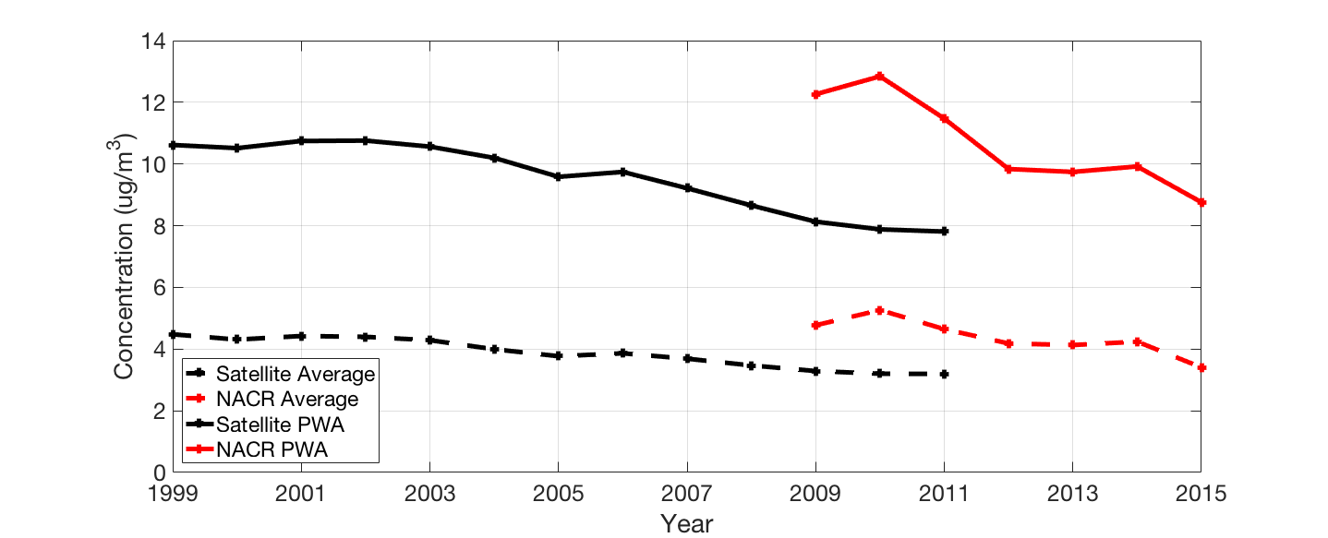

**Figure 1** US annual average PM2.5 concentration temporal trends for SAT and NACR: the simple area-weighted average over the CONUS and the population-weighted average (PWA)

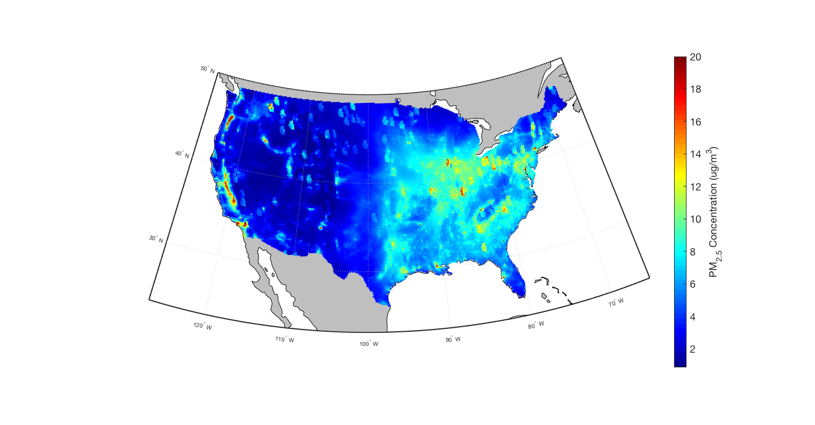

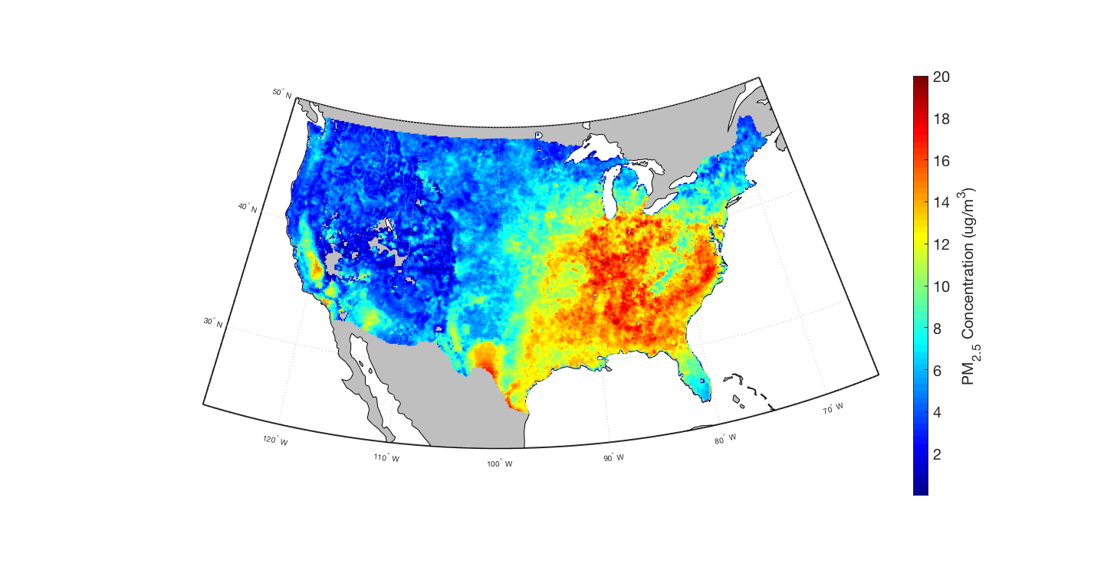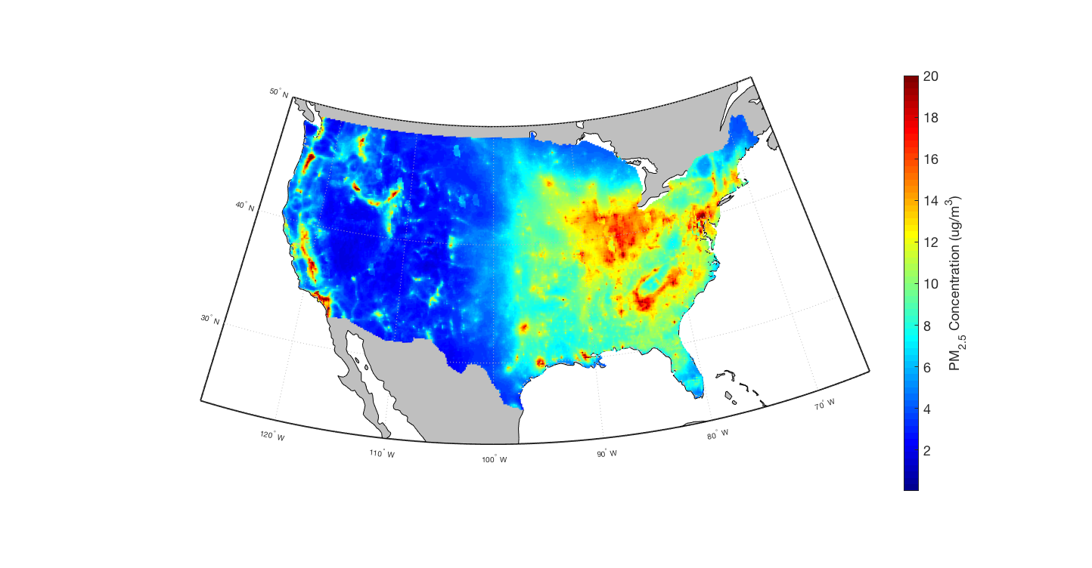

D

A

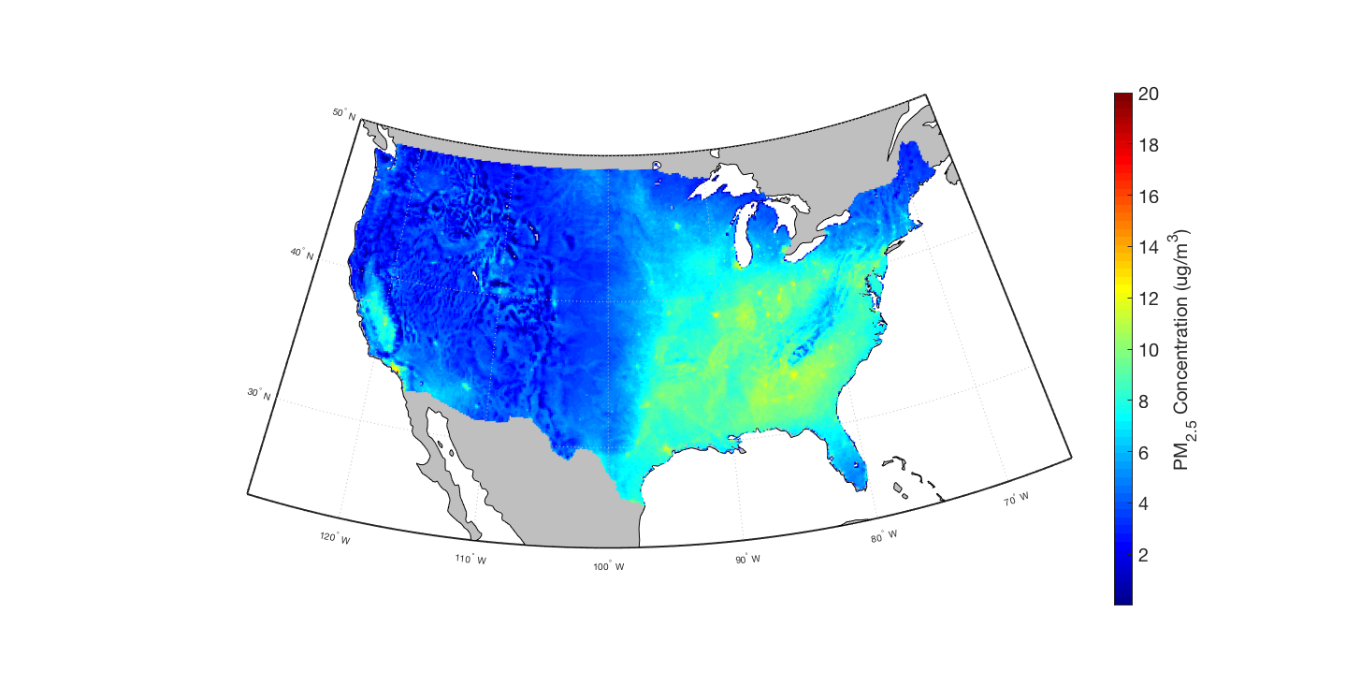

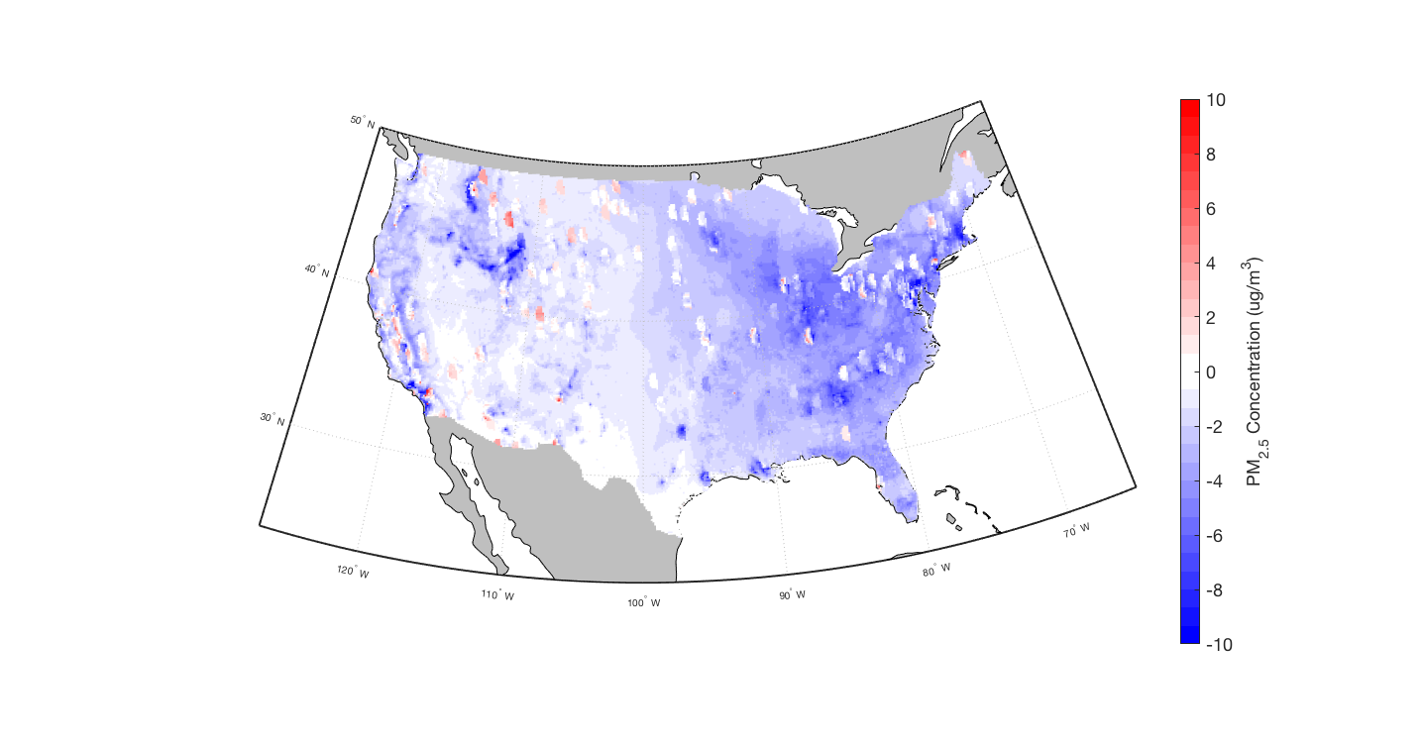

E

B

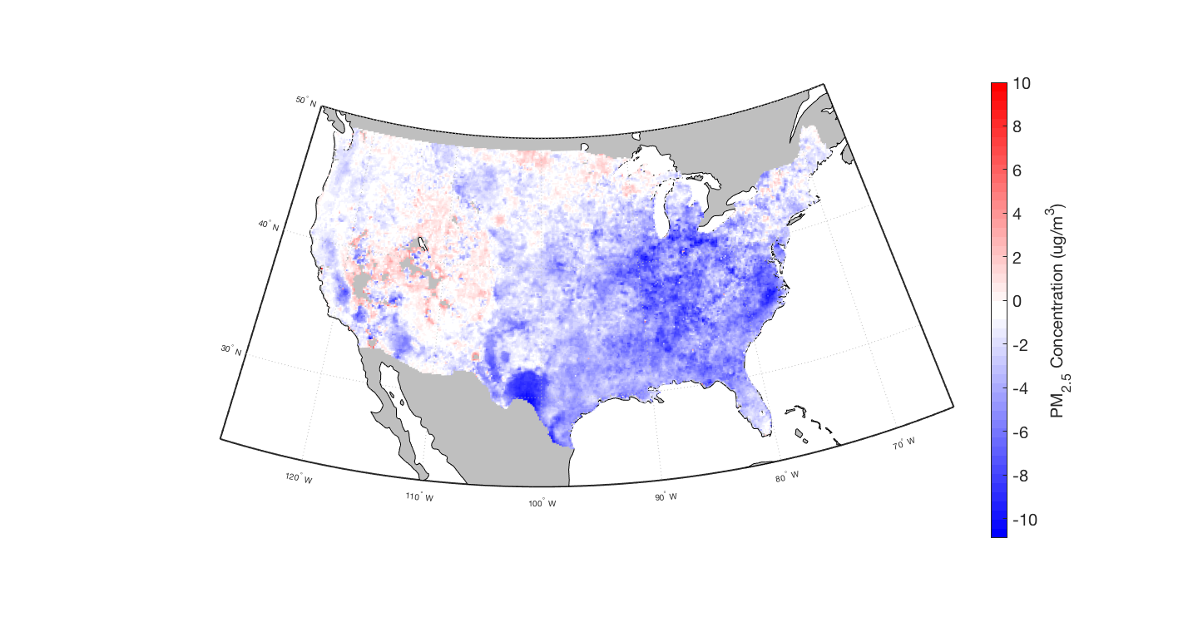

F

C

**Figure 2** Spatial trends in PM2.5 concentration: SAT 1999 (**A**), SAT 2011(**B**), SAT difference from 1999 to 2011 (**C**), NACR 2009 (**D**) NACR 2015 (**E**), NACR difference from 2009 to 2015 (**F**)

For SAT, annual average PM2.5 decreased by 0.11 ug/m3 yr-1 (2.39 % yr-1) while PWA PM2.5 decreased by 0.23 ug/m3 yr-1 (2.20 % yr-1). For NACR annual average PM2.5 decreased by 0.19 ug/m3 yr-1 (4.10% yr-1) while PWA PM2.5 decreased by 0.5 ug/m3 yr-1 (4.07% yr-1). These decreases can mainly be attributed to significant reductions in PM2.5 in the eastern US (Figure 2). Outside of major cities in California, most of the western US has only moderate decreases or slight increases. Air quality improvement within the eastern US is due to reductions in emissions, and agrees with previous studies (Gan et al. 2015; Xing et al. 2015; Zhang et al. 2018). Yearly variations in the western and central US could partially be attributed to wildfires (Dennison et al. 2014; Hand et al. 2013, 2014; Jaffe et al. 2008; Murphy et al. 2011; Spracklen et al. 2007). The eastern and southern US appear to have had the strongest reductions in PM2.5 concentration.

Between the two datasets, SAT PM2.5 concentrations appear to have stronger decreases in the specific regions of Appalachia, the Ohio Valley, coastal Carolina/Virginia, and south-western Texas, while NACR appears to have slightly larger decreases overall but fewer regions of sharp decrease. Additionally SAT shows a regional increase in the south-western US that is absent from NACR. However, when comparing the two it is important to consider that the NACR data covered a shorter period of time, meaning a smaller decrease would be expected.

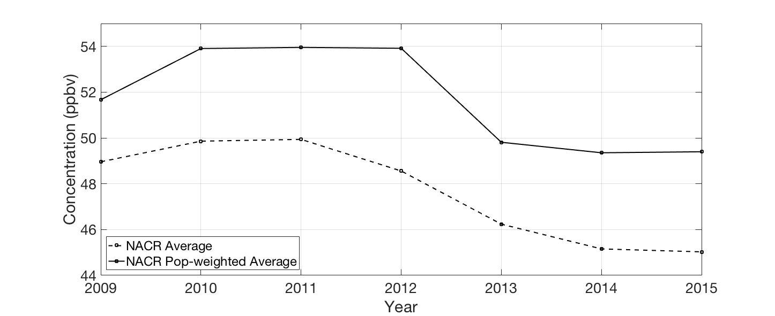

**Figure 3** US 8-hr 6 mo. O3 concentration temporal trends for NACR

Figure 3 illustrates the general temporal trends in summertime O3 from NACR. Satellite-derived O3 data was not available so NACR results are the focus of the O­3 analysis. A slight increase and stabilization of O3 concentrations occurs from 2010-2012, followed by a period of decrease. PWA O3 was much higher than spatially average O3 indicating that pollution is generally worse in urban environments. O3 data is far more variable than PM2.5 where a clearer decrease was observed. For a deeper analysis of trends in Ozone see “Comparisons with Other Studies” below.

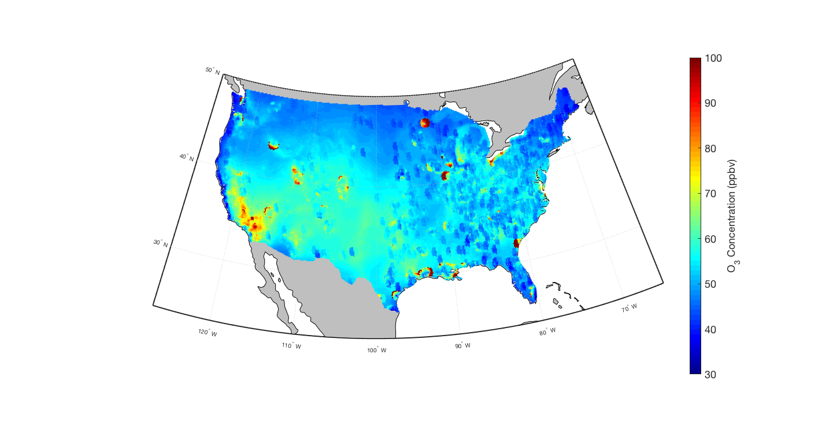

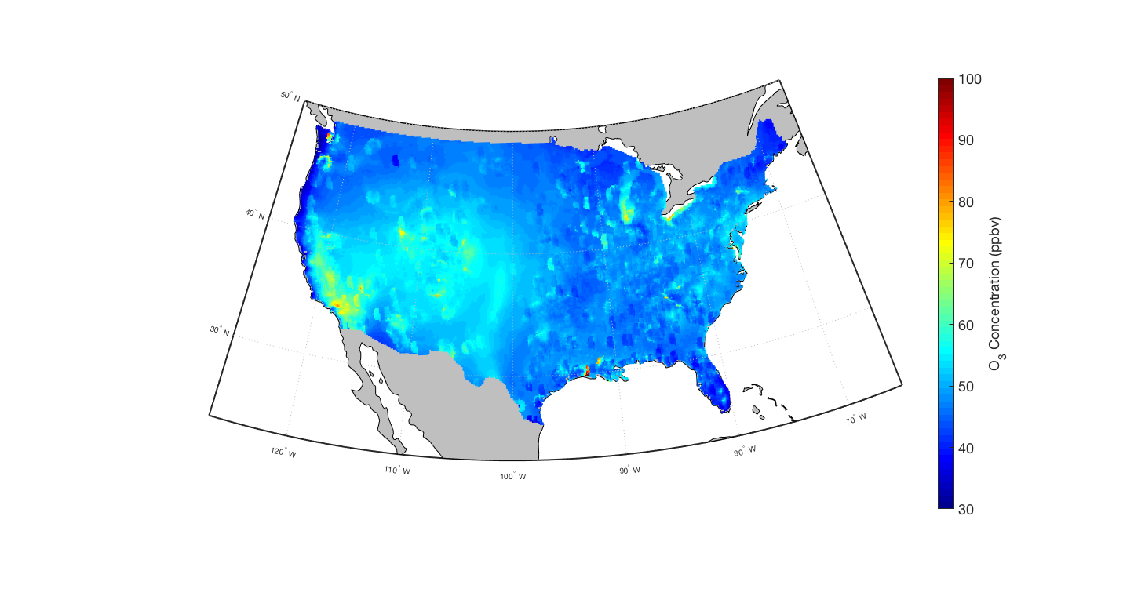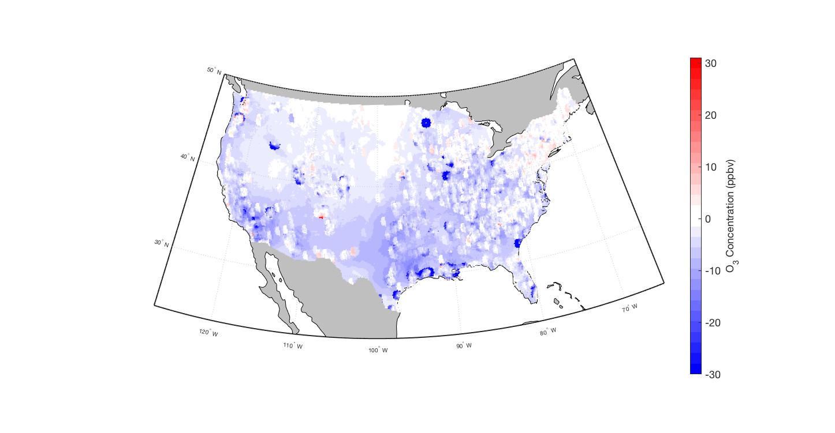

C

B

A

**Figure 4** Spatial trends in O3 concentration: 1. NACR 2009 (**A**), 2. NACR 2015 (**B**), 3. NACR difference from 2009 to 2015 (**C**)

Summertime average 8-hr max O3 from NACR decreased by 7.6% from 49.0 ppbv in 2009 to 45.2 ppbv in 2016. In the same period, PWA 8-hr max summertime O3 decreased by 5.51% from 87.1 ppbv to 82.3 ppbv. For O3, spatial changes were far more gradual when compared to PM2.5, which has been decreasing more rapidly in the US in recent years (Figures 1 and 2). Around densely populated areas (such as New York City, Los Angeles and Chicago), greater decreases in O3 concentration have been observed. Additionally, it appears that the largest decreases in O3 occurred in the southern and western US, with the northern and eastern US mostly showing little change or decreasing slightly. The eastern US saw significantly smaller relative decreases in O3 pollution than PM2.5 pollution.

**Mortality Burden Trends**

**Table 1** *Percentage of PM*2.5*-related deaths from specific diseases over all years for SAT and NACR*

|  |  |  |
| --- | --- | --- |
|  | Percentage of Deaths (SAT) | Percentage of Deaths (NACR) |
| IHD | 79.6% | 75.2% |
| LC | 9.2% | 10.9% |
| COPD | 5.5% | 7.6% |
| STROKE | 5.7% | 6.3% |

For both SAT and NACR, we see that premature deaths due to exposure to ambient PM2.5 have decreased gradually in the US in their respective timespans (Figures 5 and 6). For SAT a decrease of 58.6% was estimated from 77800 [36800, 128400] deaths yr-1 in 1999 to 32200 [7600, 70400] deaths yr-1 in 2011. For NACR a decrease of 47.5% was observed from 71100 [33700, 113300] deaths yr-1 in 2009 to 37300 [11500, 76200] deaths yr-1 in 2015. For both SAT and NACR, Ischemic Heart Disease (IHD) made up the majority of deaths due to PM2.5 (Table 1) at 79.6% and 75.2% respectively. Other health outcome percentages are listed in Table 1.

For O3, the negative health outcome of interest was respiratory disease (RESP). For NACR O3, a decrease of 3.6% was estimated from 10100 [3400, 16300] deaths yr-1 in 2009 to 9700 [2800, 13600] deaths yr-1 in 2015.

Figures 5-7 show trends in pollution-related deaths for three cases: “base”, “concentration change excluded” and “concentration change only”. Here, “base” refers to the estimation using annual values of the three inputs: mortality rates, population and concentration. For the “concentration change excluded” (or “excluded”) case, annual values of mortality rates and population are used for each yearly estimation, however, the concentration data corresponding to the first year in the time period (ie 1999 for SAT) is the only one used. For the “concentration change only” (or “only”) case, annual values of pollutant concentration are used, however, mortality rate and population data is held at the values of the first year in the time period.

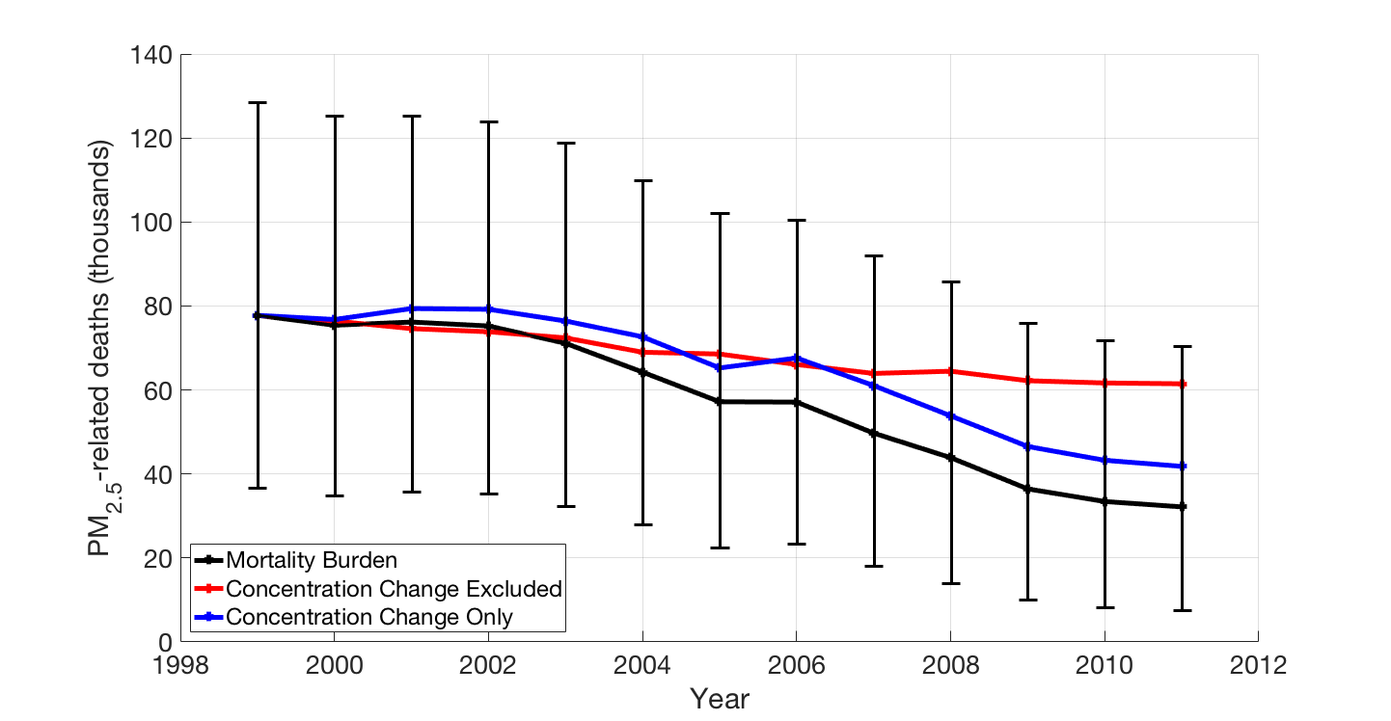

**Figure 5** Temporal trends in PM2.5 mortality burden (SAT)

From SAT PM2.5 (Figure 5), we see that since 1999 deaths related to PM2.5 have been decreasing. For most of the period, the “base” case resulted in far fewer deaths than the “excluded” case, indicating that a large proportion of reductions in premature mortality can be attributed to changing concentrations. Most of the year-to-year variation of the “base” case is caused by similar variations in the “only” case as indicated by similar shaped trends, indicating that the yearly variability of premature deaths can be attributed to changes in concentration, not baseline mortality rate or population. Towards the beginning of this period, it appears that the “only” case increases, surpassing the estimated amounts of the “excluded” and “base” cases. This is due to increased PM2.5 concentration during this period (Figure 1).

When SAT PM2.5 concentrations are held to 1999 levels throughout the period of 1999-2011, known as the “excluded” case, deaths only decrease by 21.0% from 77,800 (1999) to 61,500 (2011), driven solely by decreased mortality rates, in spite of growing population. For the year 2011, PM2.5 reductions caused 29,400 fewer PM2.5-related deaths (61,500 minus 32,100), relative to the “excluded” case where concentrations were held to 1999 values. When baseline mortality rates and population were held to 1999 values, known as the “only” case, we see a decrease of 46.2% from 77,800 (1999) to 41,800 (2011). Ultimately, both the shape and amount of deaths estimated appears to be determined primarily through change in concentration.

For NACR PM2.5 (Figure 6) we see that since 2009 deaths have been decreasing. Similar to SAT, the “base” case estimates far fewer deaths than the “excluded” case, indicating that reductions in PM2.5 concentration are responsible for decreased deaths. Year-to-year variability is characterized by the concentration; similar shapes in the trend occur between the “base” and “only” cases, but are absent from the “excluded” case, indicating that air pollution is the major factor causing the variability in deaths.

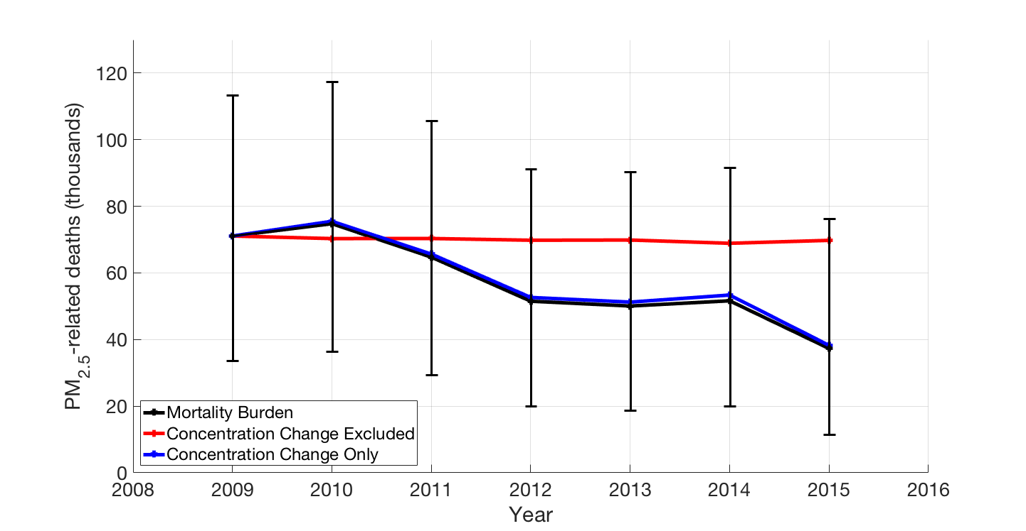

**Figure 6** Temporal trends in PM2.5 mortality burden (NACR)

When NACR PM2.5 concentrations are held to 2009 levels throughout the period of 2009-2015, in the “excluded” case, PM2.5-related deaths decrease 1.84% from 71,100 (2009) to 69,800 (2015), driven by decreased baseline mortality. In this timespan (2009-2015), improvements in PM2.5 reduced excess mortality considerably, preventing 89,000 deaths when comparing the “base” case to the “excluded” case. For the year 2015, PM2.5 reductions resulted in 32,000 fewer PM2.5 related deaths (69,800 minus 37,800) relative to the “excluded” case. When baseline mortality rates and population are held to 2009 amounts in the “only” case, we see a decrease of 46.2% from 71,100 (2009) to 38,200 (2015).

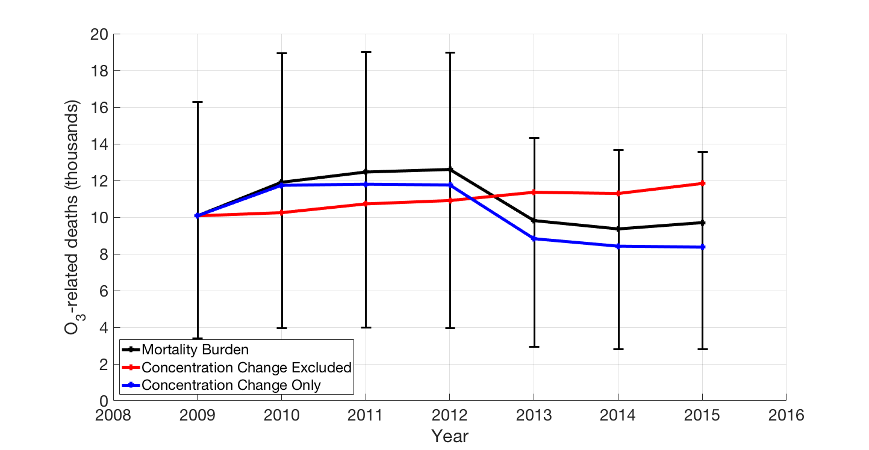

**Figure 7** Temporal trends in O3 mortality burden (NACR)

For NACR O3 (Figure 7), we again see that both the level and variability of the “base” case mortality matches closely with the “only” case. This indicates that for both O3 and PM2.5 and for both SAT and NACR, changing concentration appears to be the greatest factor influencing estimated mortality.

For NACR O3, in the “excluded” case deaths increase by 17.5% from 10,100 (2009) to 11,800 (2015), driven by a combination of increasing baseline mortality rates and population. In 2015 O3-related deaths decreased considerably, preventing 2000 extra deaths when comparing the “base” case to the “excluded” case. Additionally when baseline mortality rates and population were held to 2009 amounts in the “only” case, we see a decrease of 16.9% from 10,100 (2009) to 8,300 (2015).

From the results of the NACR study, it is difficult to ascertain how certain a downward trend in O3-related deaths is, due to the variability of the O3 data. To measure this variability, a linear regression line was constructed based on the death data points and the corresponding R2­ value was determined. NACR O3 data had an R2 value of 0.48 compared to NACR PM2.5 which had a R2 value of 0.94. However, a slight downward trend, is observed; for a clearer image of this trend, the results from the NACR dataset are combined with the EPA dataset used by Zhang et al. (2018) in Figure 13.

B

A

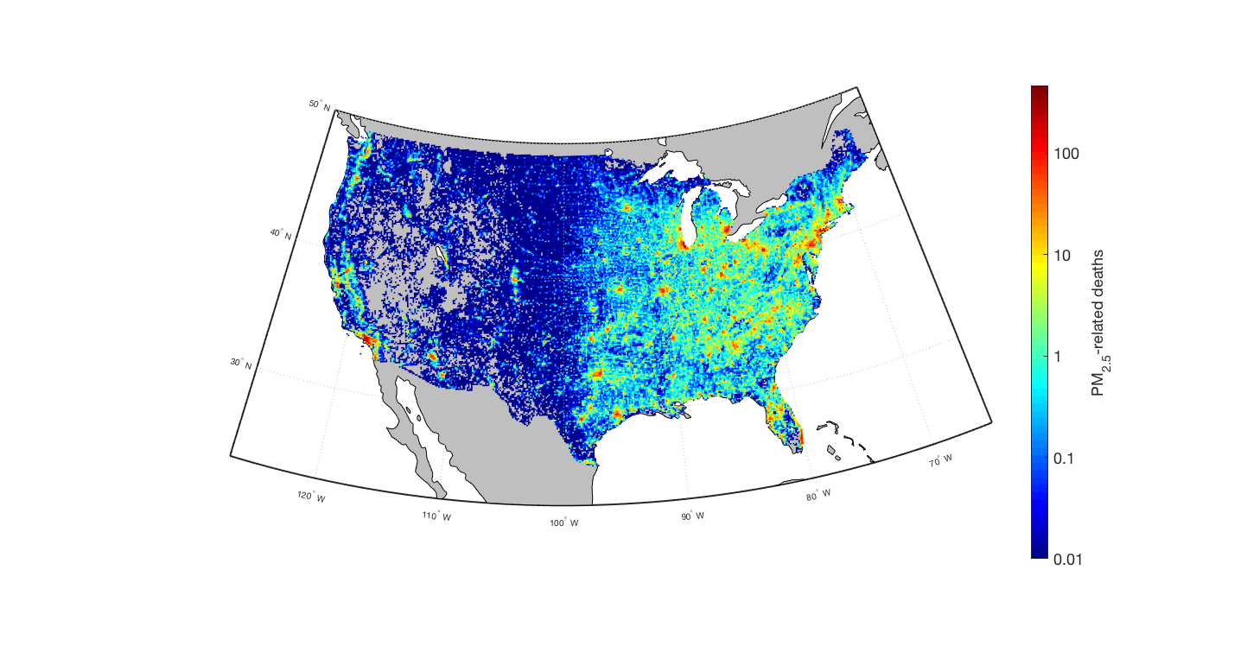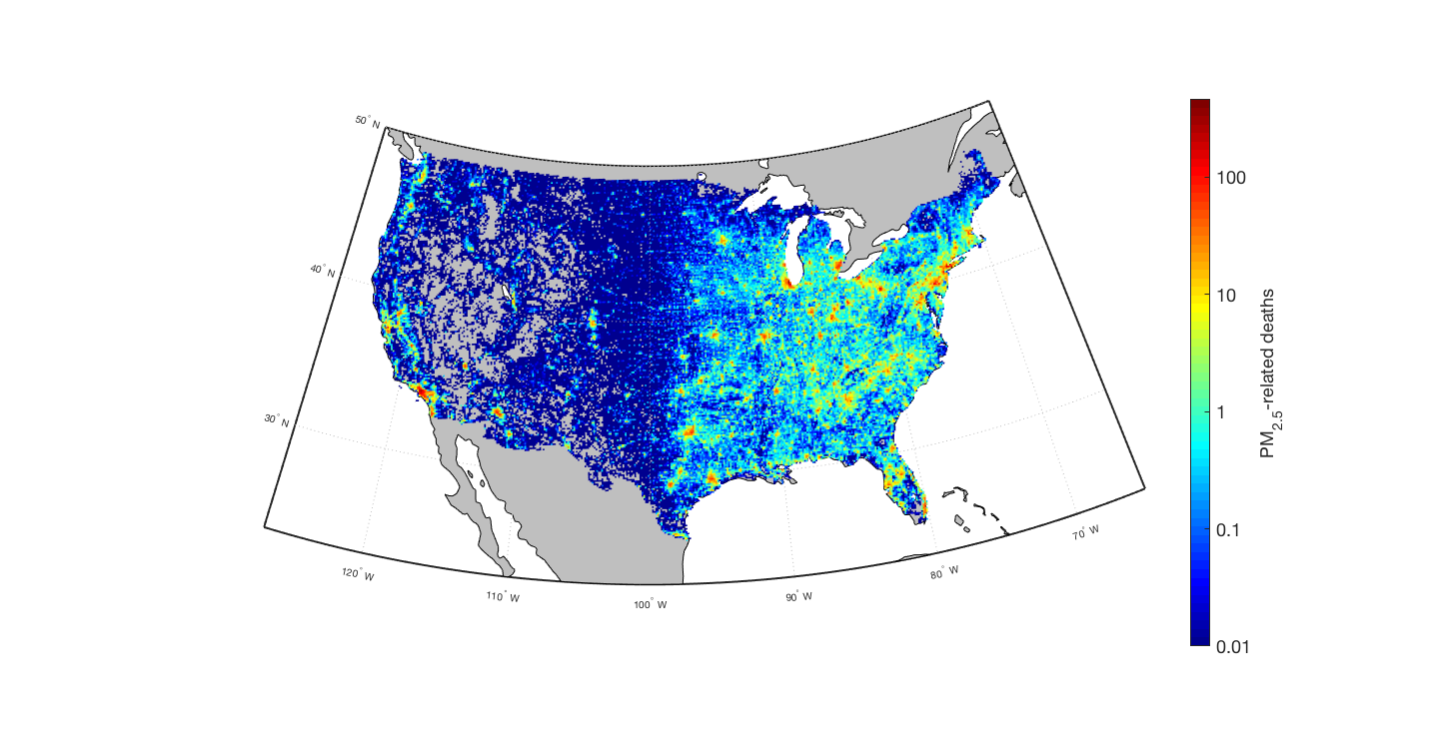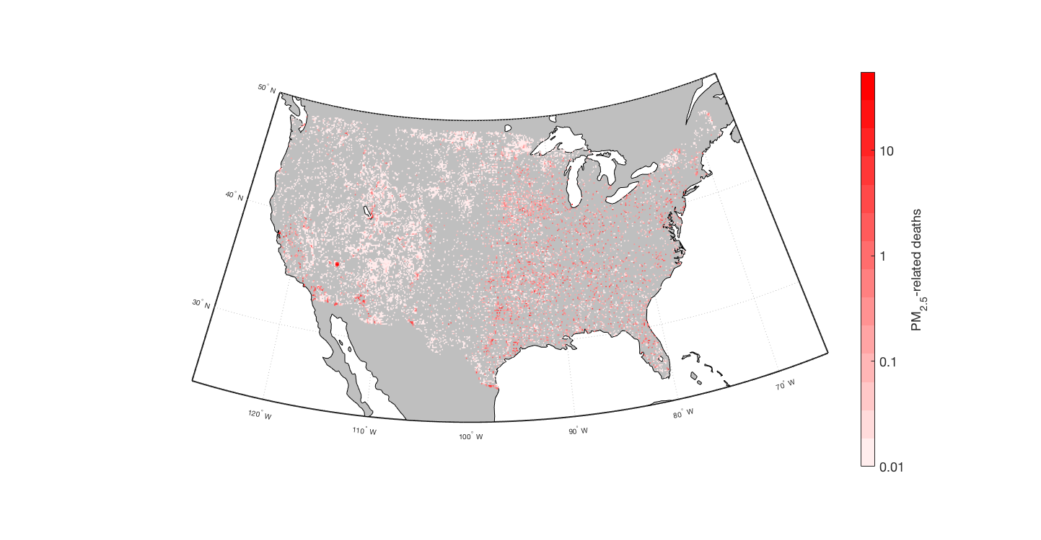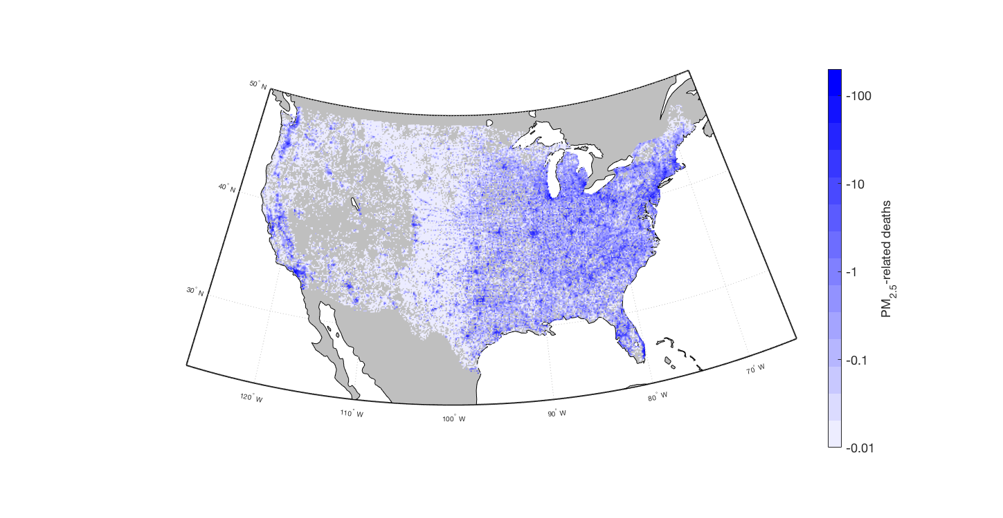

DA

C

**Figure 8** Spatial trends for PM2.5 mortality burden (SAT): in 1999 (**A**), 2011 (**B)**, and locations with an increased trend from 1999 to 2011 (**C**), and with a decreased trend from 1999 to 2011 (**D**)

Across the CONUS, PM2.5-relateddeaths decreased far more often than increased for SAT (Figure 8). More deaths occurred in the eastern US than the western US due to higher concentration of PM2.5 and a larger population exposed. The southwest and northwest showed moderate increases in deaths, with a few points in the eastern US also showing somewhat significant increases in death. In magnitude, however, decreases were far more significant than increases with largest decreases being on the order of 100, as opposed to the largest increases being on the order of 10. Regional decreases agreed well with the decreases observed in PM2.5 concentration from Figure 2c.

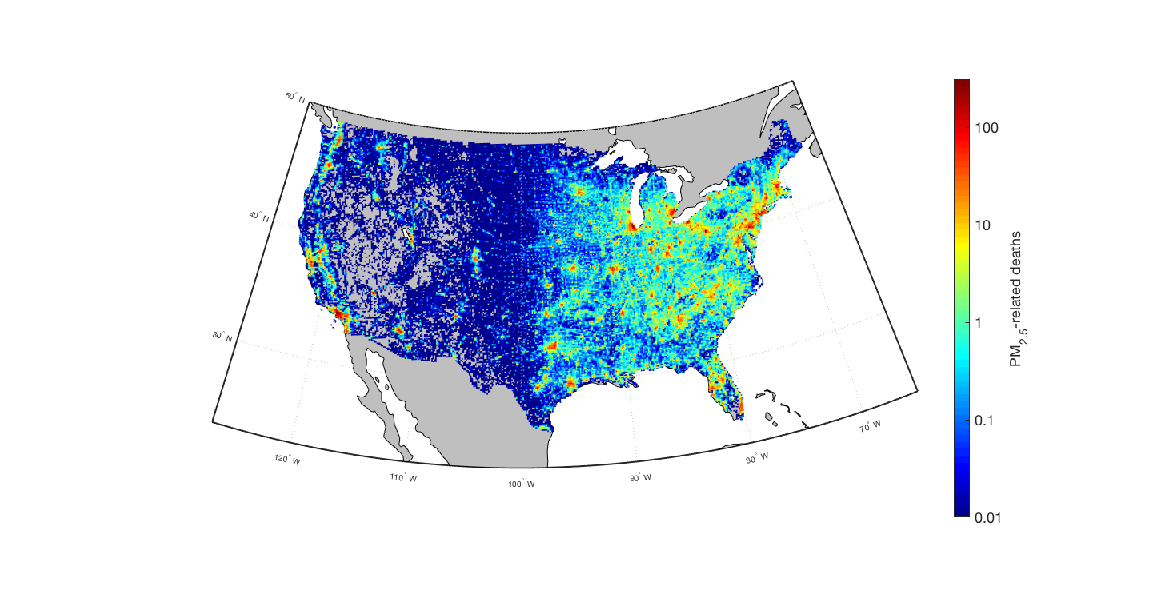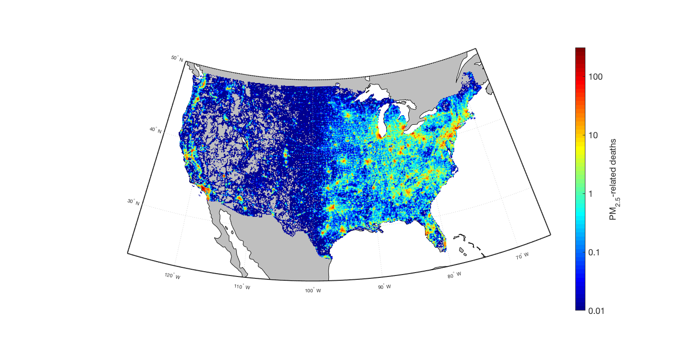

A

B

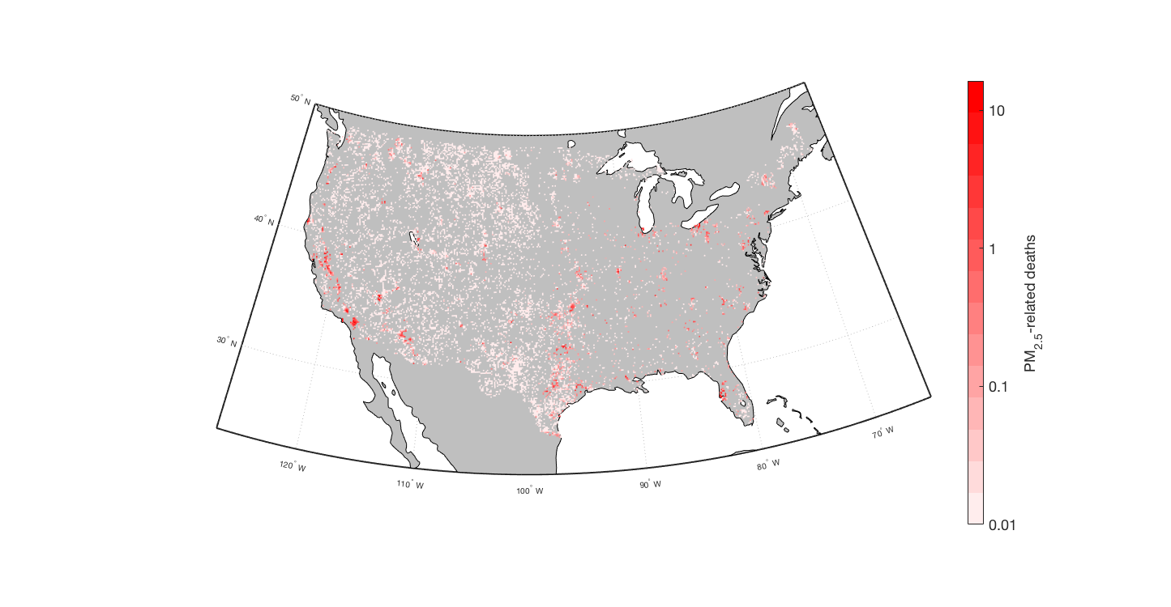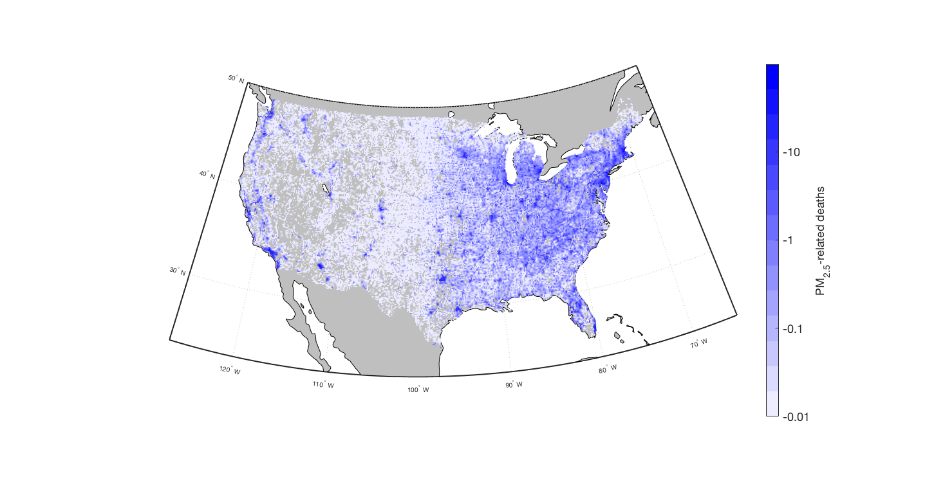

C

D

**Figure 9** Spatial trends for PM2.5 mortality burden (NACR): in 2009 (**A**), 2015 (**B)**, increased trend from 2009 to 2015 (**C**), decreased trend from 2009 to 2015 (**D**)

Similarly, for NACR (Figure 9), a majority of the CONUS saw decreases in PM2.5-related death. For the most part, spatial trends observed in the SAT data were seen in the NACR data as well. The estimation from NACR saw even fewer increases in death in the eastern US, as well as generally smaller amounts of both increases and decreases. The eastern US had even fewer points of increase for NACR while regional decreases for both datasets appeared very similar. California appeared to have the most spatial variability for both datasets, having some of the regions of sharpest increase and sharpest decrease for PM2.5-related deaths.

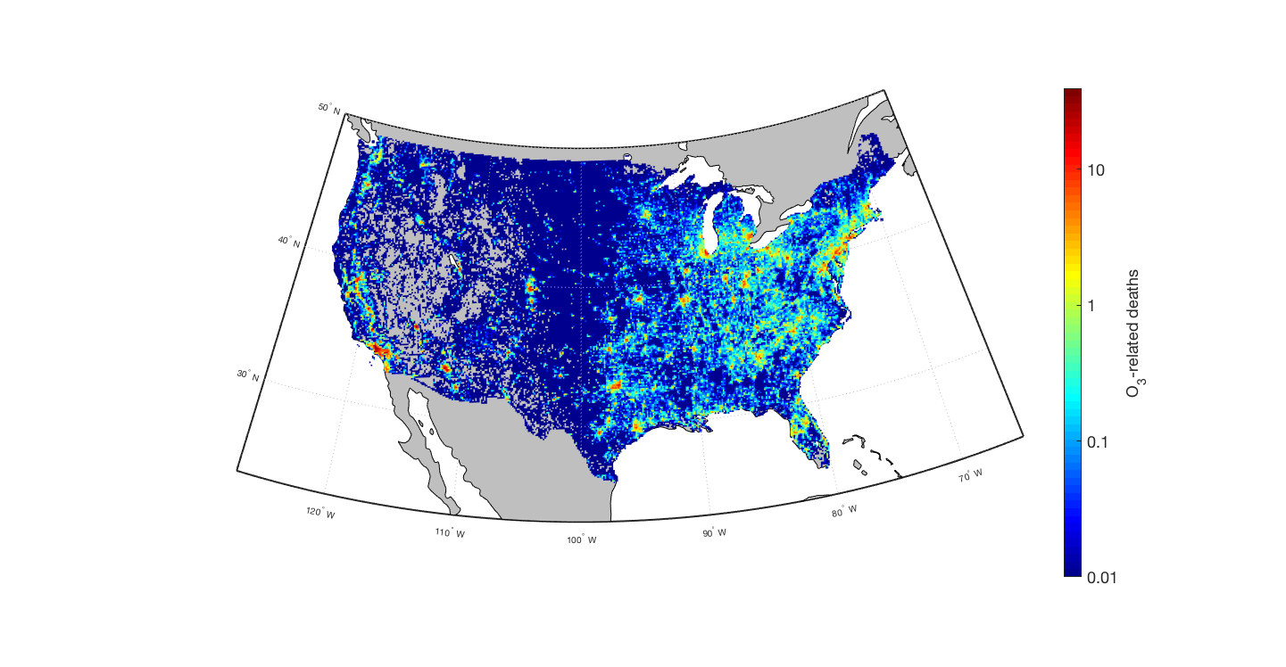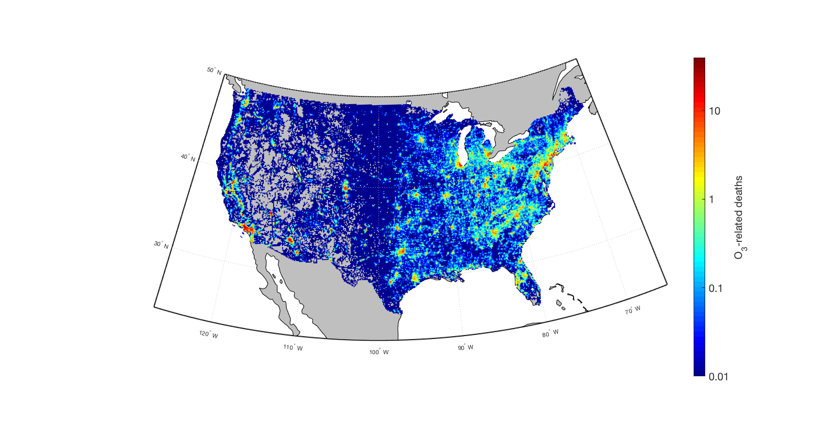

A

B

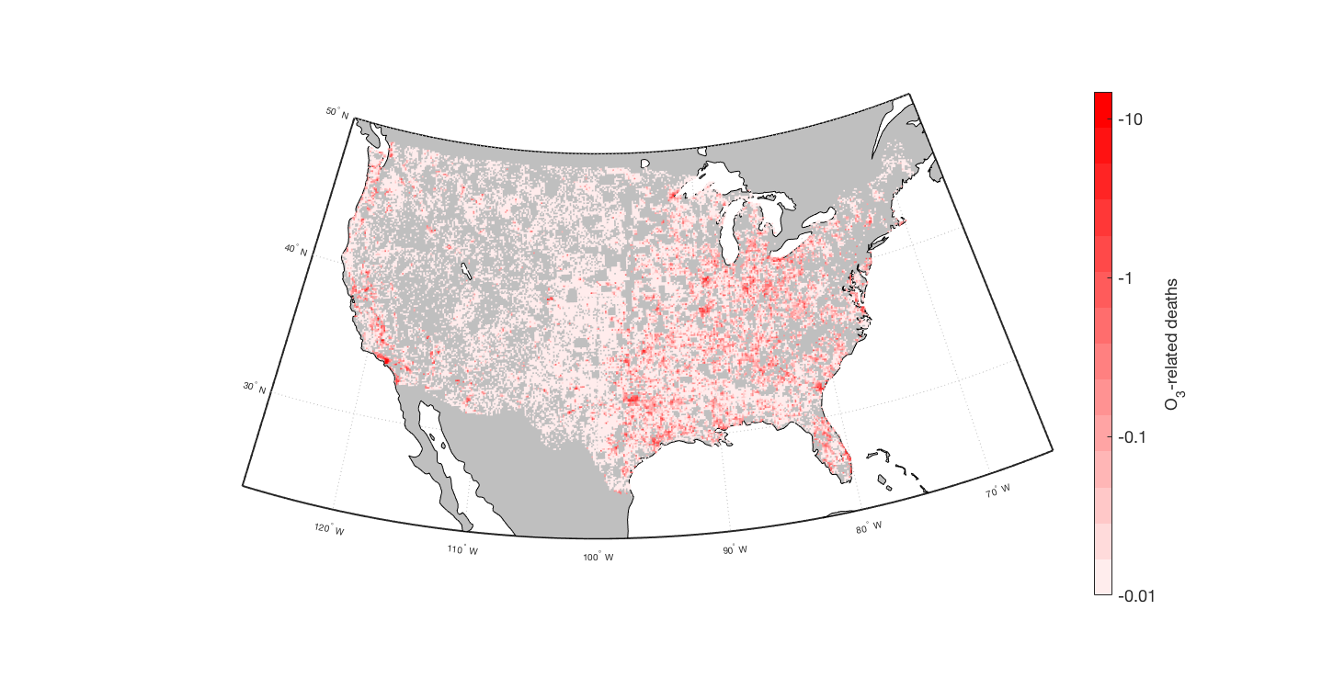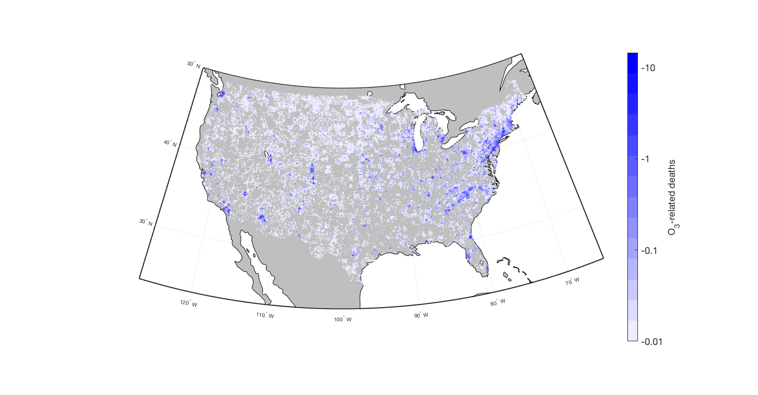

C

D

**Figure 10** Spatial trends for O3 mortality burden (NACR): in 2009 (**A**), 2015 (**B)**, increased trend from 2009 to 2015 (**C**), decreased trend from 2009 to 2015 (**D**)

For NACR O3-related deaths, there was less of a distinction between decreases and increases (Figure 10) compared to the results for PM2.5. New England was one of the regions that saw some of the greatest decreases in O3-related deaths, along with areas of southern California and coastal Washington area. However, other areas of California saw significant increases in O3-related deaths matching some of the variability seen in the PM2.5-related deaths from Figures 8 and 9.

Additionally, individual states were examined to better quantify regional trends in air pollution-related deaths and to determine the states that benefitted the most from improvements in air quality. Tables 2-4 show the three states with the most excess deaths in each category, a full list of the deaths and trends for all states can be found in the appendix.

**Table** 2 *Leading states in premature mortality and reductions for PM*2.5 *SAT*

|  |  |  |  |
| --- | --- | --- | --- |
|  | SAT | | |
|  | 1999 | 2011 | Largest Decrease |
| 1 | California  (7,360) | California  (3,920) | Florida  (-3,580) |
| 2 | Texas  (6,060) | Texas  (2,820) | California  (-3,440) |
| 3 | Ohio  (5,160) | Ohio  (2,100) | Texas  (-3,230) |

**Table** 3 *Leading states in premature mortality and reductions for PM*2.5 *NACR*

|  |  |  |  |
| --- | --- | --- | --- |
|  | NACR | | |
|  | 2009 | 2015 | Largest Decrease |
| 1 | California (8,650) | California  (6,590) | New York  (-2,620) |
| 2 | Pennsylvania (4,860) | Ohio  (2,850) | California  (-2,060) |
| 3 | Ohio  (4,250) | Pennsylvania  (2,820) | Pennsylvania  (-2,040) |

**Table 4** *Leading states in premature mortality and reductions for O3*

|  |  |  |  |  |
| --- | --- | --- | --- | --- |
|  | NACR | | | |
|  | 2009 | 2015 | Largest Increase | Largest  Decrease |
| 1 | California (1,400) | California  (1,300) | Pennsylvania  (+90) | Texas  (-190) |
| 2 | Texas (800) | Texas  (600) | North Carolina  (+50) | California  (-130) |
| 3 | Ohio (500) | Pennsylvania  (500) | Connecticut  (+40) | Ohio  (-60) |

**Comparisons Between PM2.5 Datasets**

The mortality burdens attributable to PM2.5 differed significantly between the NACR and SAT datasets. At periods of overlapping concentration data (2010, 2011) SAT mortality ranged from 68.6% (2009) to 49.4% (2011) of the NACR dataset. This lower mortality is a result of significantly lower input PM2.5 concentrations (Figure 1). To characterize this difference, all of the grid cells associated with the NACR and SAT concentrations were split into four quartiles based on population. Once split, the two datasets were compared.

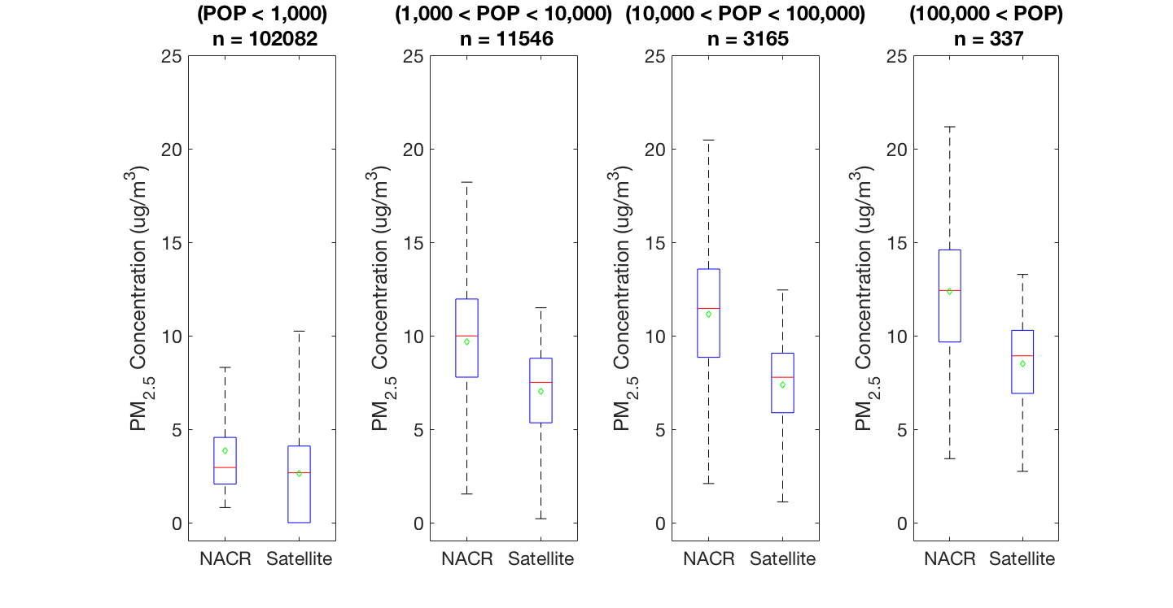

**Figure 11** PM2.5 concentration comparison between NACR and SAT for different quartiles of population

Figures 11 and 12 show data from 2011. We see that at every population bracket of interest NACR data has higher average concentration, indicated by both the red line (median) and the green diamond (mean). For larger population grid cells, especially grid cells with population greater than 1000, this trend is even more apparent with the NACR data having on average 3-5 ug/m3 higher concentration. This analysis verifies that high population grid cells have higher PM2.5 in the NACR dataset, which is responsible for overall higher mortality estimations. The modelled concentration data has both a higher average and PWA value for PM2.5 concentration.

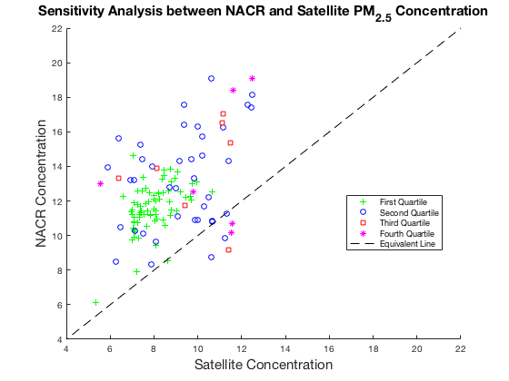

**Figure 12** Sattellite vs. modeled concentrations: dashed line indicates equivalent value, values above the line indicate higher NACR concentration in the population quantile.

Another population concentration analysis was performed by sorting all grid cells in one of a hundred evenly spaced population brackets (Figure 12). The average concentrations of each of these brackets were calculated, placed into the quartiles from Figure 11 and graphed. Nearly all of the population brackets fell above the dashed line, indicating a higher NACR than SAT concentration.

**Comparisons to Other Studies**

The mortality burdens from the two datasets used to estimate PM2.5 concentration in the CONUS were combined together with those from Zhang et al. (2018), who used a 21-year CMAQ run from 1990 to 2010 denoted as EPA (Figure 13). Since Zhang et al. (2018) used the same population, baseline mortality data, and mortality functions as the present study, differing only in resolution and therefore in the methods of regridding, we combine these together both to compare the impacts of different concentration datasets and to characterize a longer time period than allowed by a single dataset. Zhang et al. (2018) overlapped with the SAT dataset for 12 years and overlapped with the NACR dataset for two years.

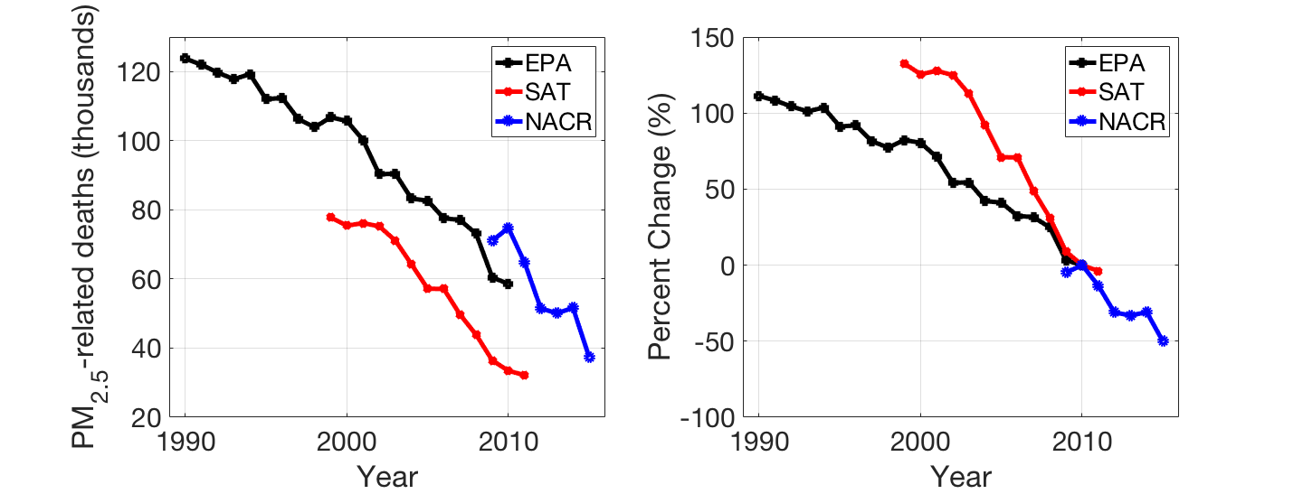

**Figure 13** Comparison of PM2.5-related deaths between datasets by absolute number (left) and percent change relative to 2010 (right)

Figure 13 shows substantial differences in the overall estimated PM2.5-related deaths, with NACR and EPA far exceeding SAT. However, we see a similar decrease percentage for all three datasets, indicating a similar rate of decrease. EPA has a trend of 3100 deaths yr-1 corresponding to a 2.5% per year decrease. Similarly, SAT has a trend of 3500 deaths yr-1 corresponding to a 4.5% per year decrease and NACR has a trend of 4800 deaths yr-1 corresponding to a 4.3% per year decrease.

The “percent-change” portion of Figure 13, which shows results as percent changes relative to 2010, one of the two years in which all three datasets overlapped, demonstrates sharper declines in the estimations from the two datasets used in this study when compared against the results from the EPA dataset. The last few years of the EPA results show a sharper decline that agrees with the results using SAT and NACR, indicating an agreement in a sharper decrease in PM2.5-related deaths in more recent years.

Across the period of overlap, on average, the SAT dataset had 24000 fewer deaths per year than the EPA dataset, with 25000 fewer deaths in 2010. In contrast, NACR had 13000 more deaths per year than the EPA in the period of overlap and 16000 more deaths in 2010. The three datasets also do not agree well in yearly variability; years with high or low deaths in one dataset are not also high or low in other datasets, and since the same population and baseline mortality are used in all cases, these differences in annual variations are due to differences in concentration estimates.

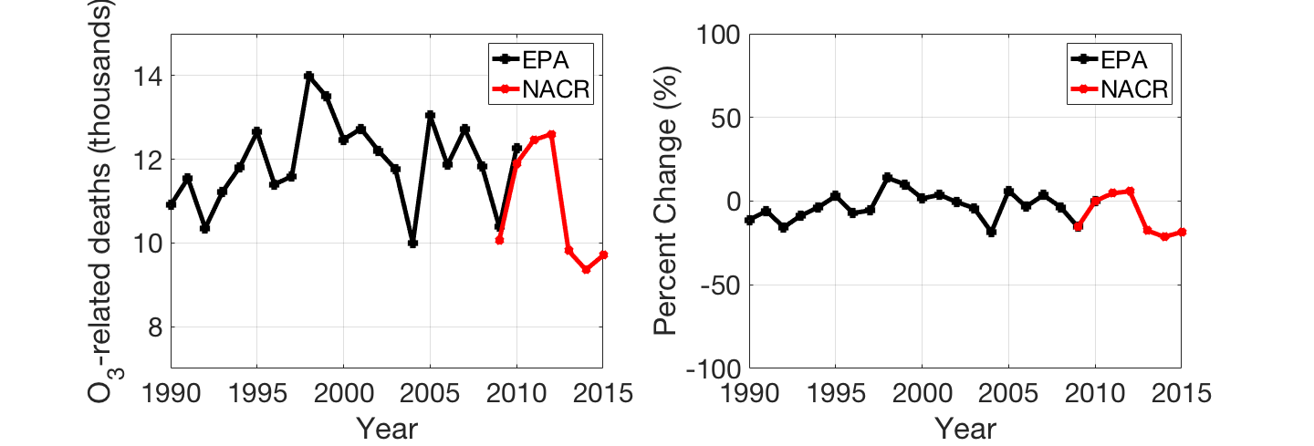

**Figure 14** Comparison of O3-related deaths between datasets by absolute number (left) and percent change (right)

For O3 mortality (Figure 14), results from the NACR dataset agree very well with the EPA dataset of Zhang et al. (2018). In the years 2009 and 2010, when the two datasets overlap, the EPA dataset leads to 310 (3.1%) and 380 (3.2%) more deaths respectively, indicating nearly identical estimations for deaths.

Across the whole time period in the EPA dataset, O3-related deaths increase from 11000 (1990) to 12275 (2010) corresponding to an increase of 12.6%. For the NACR dataset O3-related deaths decrease from 10100 (2009) to 9700 (2015) corresponding to a decrease of 3.6%. Overall, deaths from the EPA simulation increase by 0.6% per year over the entire period while the NACR simulation finds that deaths decrease by 0.6% per year. The EPA dataset shows a peak around the year 1998 with a decrease afterwards that is continued by the NACR dataset.

To investigate these trends, the period following the peak in O3-related deaths in 1998 until 2010 for the EPA dataset was compared against the NACR trend mentioned previously. In this period O3-related deaths decreased from 14000 (1998) to 12300 (2010), corresponding to a decrease of 12.2% or 0.9% per year, agreeing well with the rate of decrease from NACR (0.6% per year). From this result, it appears that O3-related mortality has been steadily decreasing since 1998, though the exact value of this decrease is difficult to determine due to the variability of the O­3 mortality burden (R2 of 0.1414 and 0.483 for EPA and NACR respectively).

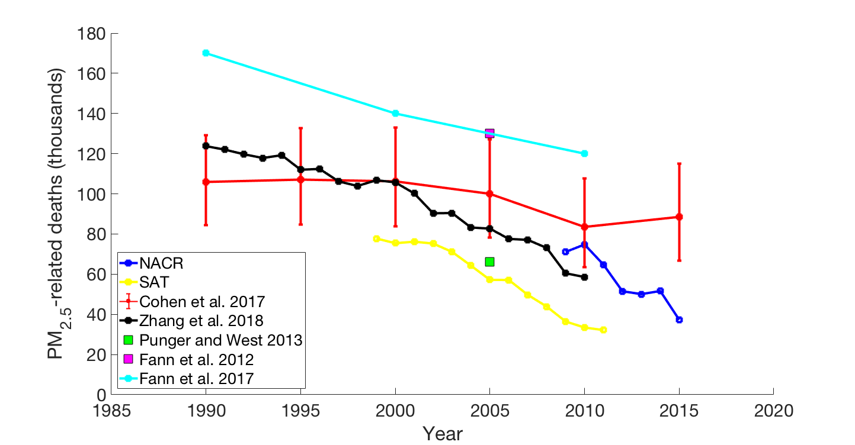

**Figure 15** Comparison of PM2.5. related deaths to previous studies. Error bars are shown for Cohen et al. (2017), error bars for NACR and SAT in this study are shown in Figures 5 and 6.

We also compare our results and those of Zhang et al. (2018), with those of other recent studies that estimated US mortality from ambient air pollution (Figure 15). These studies estimated mortality for a single year or at 5- and 10-year intervals, in contrast to the annual estimates presented here and by Zhang et al. (2018).

For PM2.5 the NACR and SAT estimations performed in this study were generally lower than other similar studies. This difference can generally be credited to the use of different risk functions. Fann et al. (2017) used a log-linear risk function with coefficients from Krewski et al. (2009). We use the IER risk function of Burnett et al. (2014) which was also used for GBD 2010 (Lim et al. 2012). For GBD 2015 (Cohen et al. 2017), the IER function of Burnett et al. (2014) was modified with new parameters. The updated IER function from GBD 2015 used a Bayesian framework to estimate the function parameters and included additional cohort studies and deaths from lower-respiratory infection (LRI). Cohen et al. (2017) used methods of estimating concentrations (Brauer et al. 2016) similar to the SAT dataset used here but on a global scale and at coarser resolution. They performed their estimation using national mortality rates; this methodology along with the inclusion of lower respiratory illness (LRI) deaths could be responsible for the differences between Cohen et al. (2017) and our estimates using SAT.

The results from this study (SAT and NACR), Zhang et al. (2018, EPA) and Fann et al. (2017) all show a similar sharp downward trend which differs with the more gradual downward trend of Cohen et al. (2017), indicating that health benefits from PM2.5 reductions may be occurring quicker. The EPA dataset provided estimations within the error bars from Cohen et al. (2017) for most of the study period, but tended to have lower results as it approached the present. The SAT dataset was well outside of the error-bars from Cohen et al. (2017), although had the closest match to the results of Punger and West (2013) for the year 2005. As mentioned previously, the SAT dataset had systematically lower concentration which resulted in less deaths estimated.

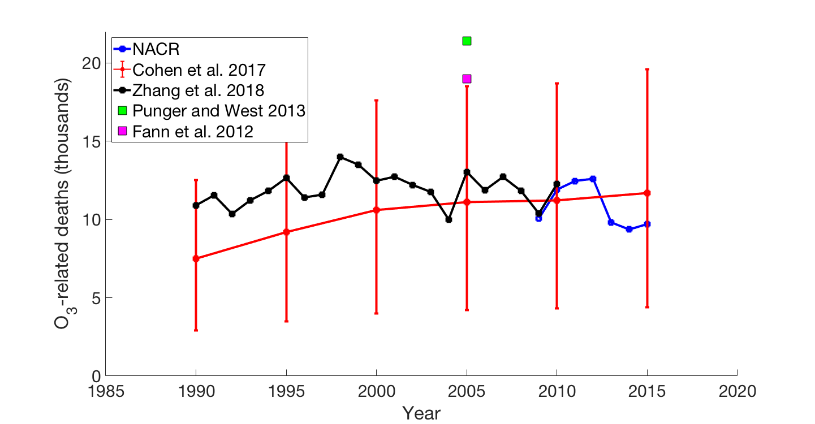

**Figure 16** Comparison of O3 related deaths to previous studies

When comparing O3-related deaths to other studies, we find that the results of this study agree well with Cohen et al. 2017 in amount. Cohen et al. (2017) used the same risk function (Jerrett et al. 2009) and based their exposure estimate on a single global model without using monitoring data to correct more biases. Because NACR used a regional-scale model and assimilated to observations, we expect that the estimations of NACR are likely more accurate. Both the EPA and NACR results are well within the error-bars for every year of overlap, in contrast to the findings for PM2.5. EPA and Cohen et al. (2017) show very similar increases in the period of 1990-1998, however, starting in 1998 the EPA results begin to decrease while Cohen et al. (2017) continue to increase, albeit, much more gradually. Trends in the EPA and NACR datasets imply that O3-related deaths have begun to decrease, whereas findings from Cohen et al. (2017) imply that O3-related deaths have continued to increase.

**CHAPTER 4: CONCLUSIONS**

Air quality within the United States has generally been improving, and with it significant reductions in air quality-related deaths have occurred. Deaths related to PM2.5 have dramatically decreased (EPA: 2.5% yr-1; SAT: 4.5% yr-1 ; NACR: 4.3% yr-1); considering the three datasets together, PM2.5-related deaths have been decreasing steadily from 1990 to 2015. From 1990 to 1998, O3-related deaths increased (3.6% per year) until a peak of around 14000 deaths in 1998. O3-related deaths have shown minor decreases since 1998 (EPA: 0.9% yr-1; NACR 0.6% yr-1). Changing concentration, as opposed to combined changes in mortality rates and population, appears to have had the most dramatic effect on the overall downward trends in deaths.

Across the two datasets, air quality has been improving. For PM2.5 it is estimated that the population-weighted annual average (PWA) concentration reduced by 28.6% and 26.6% for NACR (2009-2015) and SAT (1999-2011) respectively. For NACR O3 it is estimated that the PWA summertime (April to September) 1-hr daily maximum concentration reduced by 4.4%. For SAT and NACR PM2.5, trends in spatially average concentration are nearly identical to the PWA mentioned previously but for O3  average concentration decreases by 8.0%, nearly double the PWA value. Regions of high population, on average, saw lower reductions of O3 than the whole US but similar reductions of PM2.5.

Changing air quality is the strongest determinant of the yearly variability in mortality, and air pollution-related deaths have been estimated to be decreasing. If PM2.5 concentrations had remained at 1999 levels (“excluded”) then deaths would have only reduced by 21.0% (SAT). If baseline mortality rates and population had remained at 1999 levels (“only”), deaths would

have reduced by 46.2%. Changing concentration has a considerably greater effect on reductions than changing mortality rates and population. In 2011 alone, improvement in PM2.5 since 1999 avoided 29,400 deaths (SAT). If the PM2.5 concentrations had remained at 2009 levels then excess deaths would have only reduced by 1.84% (NACR). In 2015 alone, improvement in PM2.5 avoided 32000 extra deaths (NACR). The simulated NACR data had significantly higher amounts of deaths when compared to the satellite data, attributable to higher base concentration values.

If the O3 concentrations had remained at the 2009 levels then O3-related death would have increased by 17.5%. In this timespan (2009-2015) improvements in O3 reduced mortality considerably when compared against mortality if O3 had remained at the 2009 levels. In 2015 alone, improvement in O3 avoided 2000 deaths.

When looking at the trends for O3 consideration of the inherent variability in the data is necessary. Though a trend towards improved ozone concentration and deaths has been observed since 1998, O3 variability remains high with R2values of 0.14 and 0.43 for the EPA and NACR datasets.

The numbers of deaths differ when using different datasets. The trends from SAT, NACR and EPA match the sharper downward trend of Fann et al. (2017) when compared to the more gradual trend of Cohen et al. (2017). Accounting for year-to-year county-level population and mortality rates, as done in SAT, NACR and EPA, allows for a greater characterization of variability in trends, however, this introduces some uncertainties since the CDC population data between census-years is estimated using an interpolation method. For O3 EPA and NACR agreed well with the number of deaths found by Cohen et al. (2017), however EPA estimated fewer deaths than the results of Punger and West (2013) and Fann et al. (2012) for the year 2005. In trend, both EPA and NACR estimate a decrease in O3-related deaths in the period following 1998, while Cohen et al. (2017) still estimate an increase in this period.

In interpreting the findings of this study, a few uncertainties from the data sources and from our methodology need to be considered. To generate gridded geospatial datasets, both the SAT and NACR studies used chemical transport models which, though informed by monitoring data, are subject to uncertainties. We did not account for these uncertainties in our error estimations. In using the risk function, only deaths in adults aged 25 and older are considered, ignoring deaths in younger populations. Regridding both the SAT dataset and LandScan population data introduces some error into our estimations since grid cells on the border of two counties would only be assigned the mortality rate of a single county.

Despite improvements in air quality, there remain significant mortality burdens attributed to both PM2.5 and O3. For the most recent years, deaths due to PM2.5 were estimated as 32,100 (2011) and 37,300 (2015) for SAT and NACR respectively, and deaths due to O3 were 9,703 (2015) for NACR. These results imply that improvements in air quality in the US over the last two decades have had major positive effects on public health and with a continued effort to reduce air pollution greater reductions in excess mortality can be achieved.

**APPENDIX**

**Table 5** Deaths related to PM2.5 in all states from SAT, numbers are rounded to the nearest 10.

|  |  |  |  |  |  |
| --- | --- | --- | --- | --- | --- |
| **State** | **FIPS** | **1999** | **2011** | **Change** | **% Change** |
| Alabama | 01 | 2110 | 1080 | -1030 | -48.8 |
| Arizona | 04 | 700 | 410 | -290 | -41.4 |
| Arkansas | 05 | 1290 | 710 | -580 | -45.0 |
| California | 06 | 7360 | 3920 | -3440 | -46.7 |
| Colorado | 08 | 170 | 30 | -150 | -88.2 |
| Connecticut | 09 | 810 | 90 | -730 | -90.1 |
| Delaware | 10 | 300 | 130 | -170 | -56.7 |
| Florida | 12 | 4600 | 1020 | -3580 | -77.8 |
| Georgia | 13 | 2770 | 1400 | -1370 | -49.5 |
| Idaho | 16 | 20 | 0 | -10 | -50.0 |
| Illinois | 17 | 5080 | 2050 | -3030 | -59.6 |
| Indiana | 18 | 2740 | 1180 | -1560 | -56.9 |
| Iowa | 19 | 1000 | 240 | -760 | -76.0 |
| Kansas | 20 | 650 | 160 | -490 | -75.4 |
| Kentucky | 21 | 2150 | 950 | -1190 | -55.3 |
| Louisiana | 22 | 1630 | 740 | -890 | -54.6 |
| Maine | 23 | 10 | 0 | -10 | -100.0 |
| Maryland | 24 | 1650 | 820 | -820 | -49.7 |
| Massachusetts | 25 | 690 | 120 | -570 | -82.6 |
| Michigan | 26 | 3040 | 860 | -2180 | -71.7 |
| Minnesota | 27 | 410 | 120 | -280 | -68.3 |
| Mississippi | 28 | 1380 | 540 | -830 | -60.1 |
| Missouri | 29 | 2880 | 1160 | -1720 | -59.7 |
| Montana | 30 | 10 | 0 | -10 | -100.0 |
| Nebraska | 31 | 290 | 50 | -240 | -82.8 |
| Nevada | 32 | 50 | 70 | 20 | 40.0 |
| New Hampshire | 33 | 50 | 10 | -30 | -60.0 |
| New Jersey | 34 | 1810 | 750 | -1060 | -58.6 |
| New Mexico | 35 | 100 | 10 | -90 | -90.0 |
| New York | 36 | 2740 | 920 | -1820 | -66.4 |
| North Carolina | 37 | 3410 | 1350 | -2060 | -60.4 |
| North Dakota | 38 | 10 | 0 | 0 | 0.0 |
| Ohio | 39 | 5160 | 2100 | -3060 | -59.3 |
| Oklahoma | 40 | 1320 | 490 | -820 | -62.1 |

|  |  |  |  |  |  |
| --- | --- | --- | --- | --- | --- |
| Oregon | 41 | 140 | 0 | -140 | -100.0 |
| Pennsylvania | 42 | 4970 | 2270 | -2700 | -54.3 |
| Rhode Island | 44 | 150 | 50 | -110 | -73.3 |
| South Carolina | 45 | 1730 | 830 | -900 | -52.0 |
| South Dakota | 46 | 40 | 0 | -40 | -100.0 |
| Tennessee | 47 | 3080 | 1450 | -1640 | -53.2 |
| Texas | 48 | 6060 | 2820 | -3230 | -53.3 |
| Utah | 49 | 70 | 30 | -40 | -57.1 |
| Vermont | 50 | 30 | 0 | -30 | -100.0 |
| Virginia | 51 | 2010 | 730 | -1280 | -63.7 |
| Washington | 53 | 250 | 20 | -230 | -92.0 |
| West Virginia | 54 | 1000 | 290 | -710 | -71.0 |
| Wisconsin | 55 | 1130 | 180 | -950 | -84.1 |
| Wyoming | 56 | 0 | 0 | 0 | 0.0 |

**Table 6** Deaths related to PM2.5 in all states from NACR

|  |  |  |  |  |  |
| --- | --- | --- | --- | --- | --- |
| **State** | **FIPS** | **2009** | **2015** | **Change** | **% Change** |
| Alabama | 01 | 1360 | 600 | -750 | -55 |
| Arizona | 04 | 740 | 150 | -590 | -80 |
| Arkansas | 05 | 830 | 270 | -560 | -67 |
| California | 06 | 8650 | 6590 | -2060 | -24 |
| Colorado | 08 | 340 | 140 | -200 | -59 |
| Connecticut | 09 | 810 | 340 | -470 | -58 |
| Delaware | 10 | 310 | 140 | -170 | -55 |
| Florida | 12 | 2340 | 850 | -1490 | -64 |
| Georgia | 13 | 2080 | 1140 | -940 | -45 |
| Idaho | 16 | 370 | 200 | -170 | -46 |
| Illinois | 17 | 3870 | 2640 | -1230 | -32 |
| Indiana | 18 | 2440 | 1490 | -940 | -39 |
| Iowa | 19 | 990 | 430 | -560 | -57 |
| Kansas | 20 | 520 | 310 | -200 | -38 |
| Kentucky | 21 | 1660 | 800 | -860 | -52 |
| Louisiana | 22 | 820 | 400 | -420 | -51 |
| Maine | 23 | 150 | 20 | -130 | -87 |
| Maryland | 24 | 1590 | 980 | -610 | -38 |
| Massachusetts | 25 | 1620 | 240 | -1380 | -85 |
| Michigan | 26 | 2980 | 1170 | -1810 | -61 |
| Minnesota | 27 | 800 | 150 | -640 | -80 |
| Mississippi | 28 | 740 | 250 | -480 | -65 |
| Missouri | 29 | 1970 | 1110 | -860 | -44 |
| Montana | 30 | 30 | 20 | -10 | -33 |
| Nebraska | 31 | 230 | 130 | -100 | -43 |
| Nevada | 32 | 310 | 230 | -80 | -26 |
| New Hampshire | 33 | 270 | 20 | -250 | -93 |
| New Jersey | 34 | 1710 | 430 | -1280 | -75 |
| New Mexico | 35 | 220 | 50 | -170 | -77 |
| New York | 36 | 4190 | 1570 | -2620 | -63 |
| North Carolina | 37 | 2650 | 1320 | -1340 | -51 |
| North Dakota | 38 | 40 | 10 | -30 | -75 |
| Ohio | 39 | 4250 | 2850 | -1400 | -33 |
| Oklahoma | 40 | 860 | 520 | -350 | -41 |
| Oregon | 41 | 950 | 750 | -210 | -22 |
| Pennsylvania | 42 | 4860 | 2820 | -2040 | -42 |
| Rhode Island | 44 | 240 | 50 | -190 | -79 |
| South Carolina | 45 | 1290 | 620 | -660 | -51 |
| South Dakota | 46 | 70 | 40 | -40 | -57 |
| Tennessee | 47 | 2330 | 1220 | -1110 | -48 |
| Texas | 48 | 3960 | 2300 | -1660 | -42 |
| Utah | 49 | 180 | 100 | -80 | -44 |
| Vermont | 50 | 70 | 30 | -50 | -71 |
| Virginia | 51 | 1520 | 570 | -950 | -63 |
| Washington | 53 | 1080 | 450 | -630 | -58 |
| West Virginia | 54 | 710 | 210 | -500 | -70 |
| Wisconsin | 55 | 1260 | 480 | -780 | -62 |
| Wyoming | 56 | 10 | 0 | 0 | 0 |

**Table 7** Deaths related to O3 in all states from NACR

|  |  |  |  |  |  |
| --- | --- | --- | --- | --- | --- |
| **State** | **FIPS** | **2009** | **2015** | **Change** | **% Change** |
| Alabama | 01 | 190 | 160 | -20 | -11 |
| Arizona | 04 | 350 | 360 | 10 | 3 |
| Arkansas | 05 | 140 | 110 | -30 | -21 |
| California | 06 | 1450 | 1320 | -130 | -9 |
| Colorado | 08 | 270 | 310 | 40 | 15 |
| Connecticut | 09 | 70 | 110 | 40 | 57 |
| Delaware | 10 | 30 | 40 | 10 | 33 |
| Florida | 12 | 350 | 310 | -40 | -11 |
| Georgia | 13 | 320 | 270 | -50 | -16 |
| Idaho | 16 | 60 | 60 | 0 | 0 |
| Illinois | 17 | 360 | 320 | -40 | -11 |
| Indiana | 18 | 240 | 200 | -40 | -17 |
| Iowa | 19 | 100 | 90 | -10 | -10 |
| Kansas | 20 | 120 | 100 | -10 | -8 |
| Kentucky | 21 | 170 | 170 | 0 | 0 |
| Louisiana | 22 | 170 | 130 | -40 | -24 |
| Maine | 23 | 20 | 30 | 10 | 50 |
| Maryland | 24 | 180 | 190 | 10 | 6 |
| Massachusetts | 25 | 140 | 150 | 20 | 14 |
| Michigan | 26 | 320 | 350 | 20 | 6 |
| Minnesota | 27 | 110 | 100 | -10 | -9 |
| Mississippi | 28 | 120 | 90 | -30 | -25 |
| Missouri | 29 | 250 | 200 | -50 | -20 |
| Montana | 30 | 30 | 30 | 0 | 0 |
| Nebraska | 31 | 40 | 60 | 20 | 50 |
| Nevada | 32 | 160 | 180 | 20 | 13 |
| New Hampshire | 33 | 20 | 30 | 10 | 50 |
| New Jersey | 34 | 180 | 210 | 30 | 17 |
| New Mexico | 35 | 120 | 140 | 10 | 8 |
| New York | 36 | 300 | 340 | 40 | 13 |
| North Carolina | 37 | 340 | 390 | 50 | 15 |
| North Dakota | 38 | 10 | 10 | 0 | 0 |
| Ohio | 39 | 520 | 460 | -60 | -12 |
| Oklahoma | 40 | 240 | 180 | -60 | -25 |
| Oregon | 41 | 120 | 100 | -10 | -8 |
| Pennsylvania | 42 | 430 | 530 | 90 | 21 |
| Rhode Island | 44 | 20 | 20 | 0 | 0 |
| South Carolina | 45 | 190 | 180 | -10 | -5 |
| South Dakota | 46 | 20 | 20 | 0 | 0 |
| Tennessee | 47 | 280 | 260 | -20 | -7 |
| Texas | 48 | 830 | 640 | -190 | -23 |
| Utah | 49 | 80 | 110 | 20 | 25 |
| Vermont | 50 | 10 | 10 | 0 | 0 |
| Virginia | 51 | 230 | 220 | -10 | -4 |
| Washington | 53 | 130 | 140 | 20 | 15 |
| West Virginia | 54 | 110 | 100 | -10 | -9 |
| Wisconsin | 55 | 120 | 130 | 10 | 8 |
| Wyoming | 56 | 30 | 30 | 0 | 0 |

**REFERENCES**

Adhikary, B., Kulkarni, S., Dallura, A., Tang, Y., Chai, T., Leung, L. R., … Carmichael, G. R. (2008). A regional scale chemical transport modeling of Asian aerosols with data assimilation of AOD observations using optimal interpolation technique. *Atmospheric Environment*, *42*(37), 8600–8615. <https://doi.org/10.1016/j.atmosenv.2008.08.031>

Brauer, M., Freedman, G., Frostad, J., van Donkelaar, A., Martin, R. V., Dentener, F., … Cohen, A. (2016). Ambient Air Pollution Exposure Estimation for the Global Burden of Disease 2013. *Environmental Science & Technology*, *50*(1), 79–88. https://doi.org/10.1021/acs.est.5b03709

Burnett, R. T., Arden Pope, C., Ezzati, M., Olives, C., Lim, S. S., Mehta, S., … Cohen, A. (2014). An integrated risk function for estimating the global burden of disease attributable to ambient fine particulate matter exposure. *Environmental Health Perspectives*, *122*(4), 397–403. https://doi.org/10.1289/ehp.1307049

Butt, E. W., Turnock, S. T., Rigby, R., Reddington, C. L., Yoshioka, M., Johnson, J. S., … Spracklen, D. V. (2017). Global and regional trends in particulate air pollution and attributable health burden over the past 50 years. *Environmental Research Letters*, *12*(10). https://doi.org/10.1088/1748-9326/aa87be

Cohen, A. J., Brauer, M., Burnett, R., Anderson, H. R., Frostad, J., Estep, K., … Forouzanfar, M. H. (2017). Estimates and 25-year trends of the global burden of disease attributable to ambient air pollution: an analysis of data from the Global Burden of Diseases Study 2015. *The Lancet*, *389*(10082), 1907–1918. <https://doi.org/10.1016/S0140-6736(17)30505-6>

Dennison PE, Brewer SC, Arnold JD, Moritz MA. 2014. Large wildfire trends in the western United States, 1984-2011. Geophys. Res. Lett. 41:2928–2933; doi:10.1002/2014GL059576.

Dobson, J. E., Bright, E. A., Coleman, P. R., Durfee, R. C., & Worley, B. A. (2000). LandScan: A global population database for estimating populations at risk. *Photogrammetric Engineering and Remote Sensing*, *66*(7), 849–857. <https://doi.org/10.1016/j.scitotenv.2008.02.010>

Environmental Benefits Mapping and Analysis Program – Community Edition, User’s Manual, Appendices, 2017 (BenMAP 2017), <https://www.epa.gov/sites/production/files/2017-04/documents/benmap_ce_um_appendices_april_2017.pdf>.

Fann N, Lamson AD, Anenberg SC, Wesson K, Risley D, Hubbell BJ: Estimating the national public health burden associated with exposure to ambient PM2.5 and ozone. Risk Anal 2012, 32(1):81–95. doi: [10.1111/j.1539-6924.2011.01630.x](https://doi.org/10.1111/j.1539-6924.2011.01630.x) [[PubMed](https://www.ncbi.nlm.nih.gov/pubmed/21627672)]

Fann, N., Kim, S.-Y., Olives, C., & Sheppard, L. (2017). Estimated Changes in Life Expectancy and Adult Mortality Resulting from Declining PM2.5 Exposures in the Contiguous United States: 1980–2010. *Environmental Health Perspectives*, *125*(9). <https://doi.org/10.1289/EHP507>

Forouzanfar MH, Afshin A, et al. Global, regional, and national comparative risk assessment of 79 behavioural, environmental and occupational, and metabolic risks or clusters of risks, 1990–2015: a systematic analysis for the Global Burden of Disease Study 2015. *Lancet (London, England)*. 2016;388(10053):1659-1724. doi:10.1016/S0140-6736(16)31679-8.

Friedl, M. A., Sulla-Menashe, D., Tan, B., Schneider, A., Ramankutty, N., Sibley, A., & Huang, X. (2010). MODIS Collection 5 global land cover: Algorithm refinements and characterization of new datasets. *Remote Sensing of Environment*, *114*(1), 168–182. <https://doi.org/10.1016/j.rse.2009.08.016>

Gan CM, Pleim J, Mathur R, Hogrefe C, Long CN, Xing J, et al. 2015. Assessment of long-term WRF-CMAQ simulations for understanding direct aerosol effects on radiation “brightening” in the United States. Atmos. Chem. Phys. 15:12193–12209; doi:10.5194/acp-15-12193-2015.

Gan CM, Hogrefe C, Mathur R, Pleim J, Xing J, Wong D, et al. 2016. Assessment of the effects of horizontal grid resolution on long-term air quality trends using coupled WRF-CMAQ simulations. Atmos. Environ. 132:207–216; doi:10.1016/j.atmosenv.2016.02.036.

GBD 2016 Mortality Collaborators. Global, regional, and national under-5 mortality, adult mortality, age-specific mortality, and life expectancy, 1970–2016: a systematic analysis for the Global Burden of Disease Study 2016. *The Lancet*. 14 Sept 2017: 390;1084–1150.

Hand JL, Schichtel BA, Malm WC, Frank NH. 2013. Spatial and temporal trends in PM2.5 organic and elemental carbon across the United States. Adv. Meteorol. 2013.

Hand JL, Schichtel BA, Malm WC, Copeland S, Molenar JV, Frank N, et al. 2014. Widespread reductions in haze across the United States from the early 1990s through 2011. Atmos. Environ. 94:671–679; doi:10.1016/j.atmosenv.2014.05.062.

Jaffe D, Chand D, Hafner W, Westerling A, Spracklen D. 2008. Influence of fires on O3 concentrations in the western U.S. Environ. Sci. Technol. 42:5885–5891; doi:10.1021/es800084k.

Jerrett, M., Burnett, R. T., Pope, C. A., Ito, K., Thurston, G., Krewski, D., … Thun, M. (2009). Long-Term Ozone Exposure and Mortality. *New England Journal of Medicine*, *360*(11), 1085–1095. https://doi.org/10.1056/NEJMoa0803894

Krewski D., M. Jerrett, R.T. Burnett, R. Ma, E. Hughes, Y. Shi, et al., 2009. Extended follow-up and spatial analysis of the American Cancer Society study linking particulate air pollution and mortality. HEI Research Report, 140, Health Effects Institute, Boston, MA.

Lelieveld, J., Evans, J. S., Fnais, M., Giannadaki, D., & Pozzer, A. (2015). The contribution of outdoor air pollution sources to premature mortality on a global scale. *Nature*, *525*(7569), 367–371. https://doi.org/10.1038/nature15371

Lim, S. S., Vos, T., Flaxman, A. D., Danaei, G., Shibuya, K., Adair-Rohani, H., … Ezzati, M. (2012). A comparative risk assessment of burden of disease and injury attributable to 67 risk factors and risk factor clusters in 21 regions, 1990-2010: A systematic analysis for the Global Burden of Disease Study 2010. *The Lancet*, *380*(9859), 2224–2260. https://doi.org/10.1016/S0140-6736(12)61766-8

Liu, M., Huang, Y., Ma, Z., Jin, Z., Liu, X., Wang, H., … Kinney, P. L. (2017). Spatial and temporal trends in the mortality burden of air pollution in China: 2004–2012. *Environment International*, *98*, 75–81. <https://doi.org/10.1016/j.envint.2016.10.003>

Murphy DM, Chow JC, Leibensperger EM, Malm WC, Pitchford M, Schichtel BA, et al. 2011. Decreases in elemental carbon and fine particle mass in the United States. Atmos. Chem. Phys. 11:4679–4686; doi:10.5194/acp-11-4679-2011.

Punger, E. M., & West, J. J. (2013). The effect of grid resolution on estimates of the burden of ozone and fine particulate matter on premature mortality in the USA. *Air Quality, Atmosphere and Health*, *6*(3), 563–573. https://doi.org/10.1007/s11869-013-0197-8

Silva, R. A., West, J. J., Lamarque, J. F., Shindell, D. T., Collins, W. J., Dalsoren, S., … Zengast, G. (2016). The effect of future ambient air pollution on human premature mortality to 2100 using output from the ACCMIP model ensemble. *Atmospheric Chemistry and Physics*, *16*(15), 9847–9862. <https://doi.org/10.5194/acp-16-9847-2016>

Spracklen DV, Logan JA, Mickley LJ, Park RJ, Yevich R, Westerling AL, et al. 2007. Wildfires drive interannual variability of organic carbon aerosol in the western U.S. in summer. Geophys. Res. Lett. 34:2–5; doi:10.1029/2007GL030037.

Tang, Y., Chai, T., Pan, L., Lee, P., Tong, D., Kim, H. C., & Chen, W. (2015). Using optimal interpolation to assimilate surface measurements and satellite AOD for ozone and PM2.5: A case study for July 2011. *Journal of the Air and Waste Management Association*, *65*(10), 1206–1216. https://doi.org/10.1080/10962247.2015.1062439

Tong, D., Pan, L., Chen, W., Lamsal, L., Lee, P., Tang, Y., … Stajner, I. (2016). Impact of the 2008 Global Recession on air quality over the United States: Implications for surface ozone levels from changes in NOx emissions. *Geophysical Research Letters*, *43*(17), 9280–9288. https://doi.org/10.1002/2016GL069885

Van Donkelaar, A., R. V. Martin, R. J. D. Spurr, and R. T. Burnett (2015) High-resolution satellite-derived PM2.5 from optimal estimation and geographically weighted regression over North America, Environmental Science & Technology, 49(17): 10482-10491

Wang, J., Xing, J., Mathur, R., Pleim, J. E., Wang, S., Hogrefe, C., … Hao, J. (2017). Historical trends in PM2.5-related premature mortality during 1990–2010 across the Northern Hemisphere. *Environmental Health Perspectives*, *125*(3), 400–408. https://doi.org/10.1289/EHP298

World Health Organization (WHO). 2016. Ambient air pollution: A global assessment of exposure and burden of disease, ISBN:9789241511353

Zhang, Y., West, J. J., Mathur, R., Xing, J., Hogrefe, C., Roselle, S. J., Bash, J. O., Pleim, J. E., Gan, C.-M., and Wong, D. C.: Long-term trends in the PM2.5- and O3-related mortality burdens in the United States under emission reductions from 1990 to 2010, Atmos. Chem. Phys. Discuss., https://doi.org/10.5194/acp-2018-498, in review, 2018.